

**RFP 22-0571 IFC - Machine Learning (MALENA) Program**

**Technical Response**

*Date: 20th July 2022*

© 2022 Cognizant

**Table of Contents**

1. Executive Summary 4

2. Cognizant Response to IFC Annexures 6

**2.1** **ANNEX D: Requirements Matrix** 6

**2.2** **ANNEX E: Level of Effort Chart** 11

**2.3** **ANNEX F: Resumes** 12

Scrum Master | Shankar Khatri 12

React Developer | Azeez ul Rahaman Shaik 16

Power BI Developer I | J. Nageswaraiah 17

Power BI Developer II | Praveen MR 21

UX Designer | Vivek Marimuthu 23

Data Engineer | Asish Kumar 25

Cloud Engineer | Karthik Tej Chatla 26

Tester | Annie Sheba 29

Tester | Rohit Sharma 31

3. Cognizant’s Point of View (POV) 32

**3.1** **Program Objectives and Engagement Scope** 32

3.1.1 Program Goals and Objectives 32

3.1.2 Engagement Scope 33

In Scope 33

Out of Scope 35

3.1.3 Assumptions and Dependencies 36

**3.2** **Implementation Methodology and Execution** 37

3.2.1 Implementation Methodology 37

3.2.2 Execution Model 37

3.2.3 Scrum Teams Aligned to Value Streams 38

**3.3** **Engagement Governance** 39

3.3.1. Governance Model 39

3.3.2. Change Request Management 40

4. Cognizant’s Capabilities and Experience in executing similar engagements 41

**4.1** **Cognizant’s Capabilities** 41

4.1.1 UX Capabilities 41

4.1.2 Web Development Capability 42

4.1.3 Data Science Capabilities 42

4.1.4 Azure Data Capabilities 45

Azure Synapse and ADF Best Practices 46

4.1.5 Power BI Capabilities 47

**4.2** **Cognizant’s Experience in executing similar engagements** 50

4.2.1 Experience at World Bank 50

MALENA Success Story 50

World Bank Intranet Modernization 51

4.2.2 POWER BI Experience 52

#1: Embedding Power BI Reports into Third Party App 52

#2: Power BI Dataset Refresh through Power Automate 53

4.2.3 NLP Experience 54

#1: Digital Content Ranking Program 54

#2: Identify emerging risks with Chat Monitoring of Credit card customers 55

#3: Audit Review Tool 55

4.2.4 MLOps Experience 56

#1: Automated model management and MLOps for US Pharma Major 56

4.2.5 Azure and Other Similar Experience 57

#1: Data Landscape Modernization @ Logistics company 57

#2: Document Classification and Processing @ A Leading Regional Bank in US 57

#3: Personalized Marketing @ A Top 5 Wall Street Firm 58

# **Executive Summary**

Cognizant Technology Solutions (“Cognizant”) is thankful to World Bank Group (WBG) and IFC for providing an opportunity to respond to RFP NO. 22-0571 IFC - Machine Learning (MALENA) Program and is excited at the prospect of partnership with IFC on this initiative. It would be a great privilege for us if the bank chooses us as a strategic partner for this initiative. At the start of our relationship back in 2012, we vowed to bring the best people, technologies, processes as well as innovation and thought leadership to help the bank succeed in its initiatives. Now we are proud to say that we have been instrumental in strengthening the technology backbone, innovating, and transforming in true partnership with IFC as the technology and demands changed over time. We believe our passion, partnership, breadth of capabilities, depth of industry/domain knowledge and client-centric approach reflects in our proposal and related discussions as well. We are confident that you will find our response as thorough, service propositions compelling, and Cognizant capabilities suited to meet your needs – not just for today, ‘here and now’ but for the future as well.

Cognizant is best known in the industry for customer intimacy as well as the sustainable value we provide in addition to cost competitiveness. Being a trusted long-term partner, we are confident that our business-focused, consultative, and collaborative approach, combined with our experiences in executing similar engagements would be a credible and valued partner to IFC. Cognizant understands the project objectives of IFC, and the World Bank Group and our proposal seeks to address them in an efficient manner with complete adherence to IFC’s prescribed guidelines, sustainability standards and approved technology stack. Cognizant believes we can partner IFC in executing this engagement successfully because we understand the importance and urgency of this project and remain committed to providing IFC the best of Cognizant’s thinking and capabilities. As such, we have analyzed inputs from prior work and developed the proposal.

**Cognizant - IFC CIT Engagement Journey**

Cognizant has been a trusted partner since 2012, right from the inception of this IFC engagement, consistently delivering high quality products as part of this portfolio. The below illustration highlights the key tenets of our partnership.

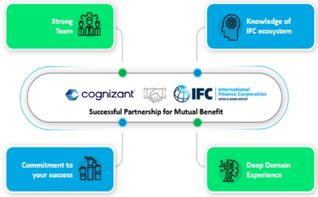

***Illustration 1: Key Tenets of the Cognizant – IFC partnership***

Following are **key highlights** to meet IFC’s objectives:

* We have brought together **the right talent**, **best practices**, **hands-on learnings,** and **proven methodologies** to **ensure success for this program**. Cognizant has the “A” team with the right mix of domain and technology capabilities that can deliver the services in scope from day1.
* **Highly experienced ‘Ready to Go’ team:** Given the time sensitive nature of the project, we have **identified and mobilized a highly experienced team** to begin the engagement with the prescribed start preference.
* **Cognizant’s Role in MALENA Phase 1 & 2:** Cognizant is key driver in implementing the major functionality and revamping the new user interface in MALENA. Our contribution in success is further elaborated in ***Section 4.2.1 (MALENA Success Story)******.***
* **We understand IFC’s landscape:** Cognizant has been involved in providing IT services to IFC since 2012. Our partnership has delivered several strategic and transformational projects successfully. We understand IFC’s culture and business and are confident of bringing in all our lessons learnt to best use in this engagement.
* **We bring the requisite Industry Experience and subject matter expertise:** We bring relevant experience of executing similar engagements for our customers across industries globally. It gives us a unique edge to envision the dynamics and challenges of such engagements, and ability to make proactive efforts to address and execute IFC’s engagement goals successfully.
* **Leverage our strategic partnerships and alliances:** We will leverage our partnership with Industry renowned experts to provide you the best-in-class capabilities. Our partners are the established leaders and innovative disruptors of the world. Our collaboration with them is designed to help your business grow.
* **Committed to engagement success:** Cognizant would like to reiterate its commitment to IFC’s strategic initiatives and will be a trusted partner working alongside IFC to achieve its long-term and short-term organizational objectives. Cognizant is committed to bringing in a range of initiatives which will strengthen the existing relationship with IFC and will help collaborate with WBG in achieving its future strategic objectives.
* **Executive relationships:** The support we have received from the IFC team in prior engagements and the depth of our relationship adds a degree of transparency into the project’s execution and an added dimension of control for IFC’s executive team.

Cognizant would like to reiterate its commitment to IFC’s strategic initiatives. Cognizant understands that IFC is embarking on modern technology outlook and transformation perspectives. We will be a trusted partner working alongside IFC to achieve its long-term and short-term organizational objectives. The length and breadth of knowledge that Cognizant has acquired over the last 9+ years while working with IFC coupled with the deep industry knowledge that Cognizant has acquired globally working with similar other clients makes it a well-suited partner for IFC. Cognizant believes that our industry leading practice capabilities and experience, our handpicked team and our proven record of accomplishment strongly positions Cognizant as the strategic partner of choice for this engagement.  We look forward to our success together.

# **Cognizant Response to IFC Annexures**

## **ANNEX D: Requirements Matrix**

| **Section** | **Requirement** |
| --- | --- |
|  | **Evaluation Criteria #1 in Section 4.3 in Annex A (Instructions to Offerors)** **(e.g., Methodology and approach in undertaking the defined work)** |
|  | Describe your understanding about the scope of work.  ***Offeror’s Response:***  Please refer to ***Section 3.1.2*** in this Technical Response document for Cognizant’s understanding of the program objectives and the scope of work. |
|  | Describe your assumptions, if any, made in your proposed methodology.  ***Offeror’s Response:***  Please refer to ***Section 3.1.3*** in this Technical Response document for a detailed list of assumptions. |
|  | Describe the ability of the firm to organize the team in such a way as to perform the services outlined in the SOW.  ***Offeror’s Response:***  Cognizant has assembled a team for this engagement which is carefully evaluated and selected to fulfil all the services in scope. Each of the proposed resources have the relevant skills and experience. Any tasks assigned will be carefully evaluated for impact, estimated, and discussed with WBG IT Project Manager prior to start of work. Any dependencies or hurdles that can come in the way of timely execution or impact quality will be brought to the notice of WBG IT Manager and his/her assistance would be sought for resolution.  Cognizant’s ability to organize its delivery team to perform the services in the scope of this RFP has been provided in detail in ***Section 3.3 Engagement Governance*** which provides a deep dive into the aspects referred to above.  Resumes of proposed personnel have been provided in ***Section 2.3 Annex F*** in this Technical Response document. |
|  | Explain in detail your plans for ensuring that the work is achieved on a timely basis.  ***Offeror’s Response:***  Cognizant proposes a robust engagement governance supported by the delivery structure with clear goals, roles, and responsibilities. Our Engagement Governance model takes a holistic approach and tracks the engagement at various levels to ensure that all aspects of the engagement including resource management, project delivery, infrastructure, quality processes and financial issues are addressed in a timely and effective manner. Cognizant will follow standard governance model to manage the escalations.  There will be strong delivery oversight provided by delivery leadership for this engagement to make sure the engagement is successful and any escalations that need to be immediately addressed. The Cognizant Governance model that manages and operates the breadth and depth of our service lines, is designed in an intuitive manner for our customers. Our clients are presented with key personnel whom they can approach for any needs – be it service delivery, operations, or opportunities. Our Leadership encourage the account teams to foster every relationship such that it remains lively, beyond an engagement.  Cognizant has provided a detailed Delivery and Execution approach for this engagement to ensure the work is achieved on a timely basis. Please refer to ***Section 3.3 Engagement Governance*** which provides details.  Resumes of proposed personnel have been provided in ***Section 2.3 Annex F*** in this Technical Response document. |
|  | Describe the escalation process in case that the work is not carried out timely or are carried out with inadequate quality level or inadequate confidentiality or security protection  ***Offeror’s Response:***  At Cognizant we are proud to have built a culture attuned to anticipating and understanding customers’ needs, working in close partnership with them, to make their businesses stronger — more productive, more profitable, more capable of capturing market opportunities — and thus making it more valuable. We have different mechanisms as listed below to gather feedback on the services provided to the customer, devise action plan and focus to improve the service continuously.   * Standard formal feedback mechanisms are institutionalized at definite milestones in engagement life cycle. Inputs are solicited on predefined parameters. * Engagement Delivery Partner (EDP)/Client Partner (CP) Interactions – Every account will have a dedicated EDP/CP, who will engage with customer periodically. These discussions are focused on business strategy and planning, solution architecture, industry market trends etc. * Contractual Feedback & Vendor Feedback – A mechanism to gather insights on quality of service, Process maturity, overall level of satisfaction * Steering committee review, Engagement Governance review – Formal connects with customer sponsors with focus on overall governance, planning, innovative solution offerings, communication, and resolution of issues etc.   **Well-aligned Governance Model:** Strong executive commitment and Steering Committee to govern relationships and provide continued oversight for meeting delivery expectations from all vendors on an ongoing basis. Regular cadence at all levels of governance to ensure continuous measurement and feedback.  **Handling Customer Complaints**  Cognizant handles all complaints and issues with a standard approach through its Issue and Escalation management process.  **Issue management**  An issue is any item that may threaten the success of, or impede the progress of the project - i.e., causes a delay, changes the direction, impairs the solution, hinders the quality, alters the deliverable content, or increases the cost. Issue management is an everyday process with formal follow-up and resolution as quickly as possible for the teams to proceed with their activities.  The main objectives of issue management process are:   * To provide a mechanism for capturing, tracking, assigning, investigating, and resolving issues that arise as part of the project * To help the project work stream members to minimize the occurrence of any situation that:   + reduces the effectiveness and efficiency of their work   + compromises the ability to meet stakeholder needs and requirements   All project issues are logged in a central place, assigned to an individual, analyzed in detail and actions plans are identified for resolving the issue. The action plans are reviewed and implemented to resolve the issue. The project manager ensures that all project issues are logged, all issues have proper status and are resolved on time without impacting the project. The Project manager tracks the issues from the time they are logged till closure.  At Cognizant, we proactively identify risks to ensure sufficient lead time for mitigation. Even though if any undesirable events impact our service delivery, Cognizant’s Escalation Management process helps win back client’s confidence and trust through effective corrective and preventive actions.  For our engagement with WBG, we will define the escalation process at the onset of the project in consultation with you. Through periodical review meetings we will facilitate the escalation procedure. WBG can escalate via any communication channel – be it during project discussion or through email/verbal communication. Cognizant Project Manager will acknowledge the escalation and log it into Escalation Management portal.  At Cognizant we follow a structured process for Escalation Management that helps:   * Assess the impact of an escalation * Assign the right stakeholders to remediate * Support appropriate intervention to manage relationship * Communicate, act, learn and prevent future recurrences   Through periodical review meetings, Cognizant will facilitate the issue escalation procedure. The frequency of the meetings will be mutually decided, and issues will be escalated to the predefined roles. Depending upon the severity of the problem, time limits will be defined for escalation to higher levels of management. There could be some situations that might demand simultaneous escalation to all levels.   |  |  |  | | --- | --- | --- | | **Issue Level** | **Description** | **Impact** | | Critical | The project activities are stalled and there is no work around available | High | | High | The project activities are stalled but there is a work around available | Medium | | Low | The project activities are not impacted, but resolving the issue will help improve the effectiveness of implementation | Low |   If directed by WBG, suitable changes in the escalation structure, if necessary, will be defined and documented. This approach enables effective handling of issues/escalations across project level, engagement level and executive level. A Root Cause Analysis is performed for each escalation and learnings are implemented to prohibit recurrence. Typical escalation modes include emails/phone conversations, video/teleconferences, tools such as PMO portal and issue tracking system. |
|  | If any subcontractor is used, provide the name and address of such vendors, and its focal contact person’s name and detailed contact information, as well as the scope of responsibilities of the subcontractors as related to the WBG requirements.  ***Offeror’s Response:***  Cognizant does not envision the usage of any sub-contractors as part of this engagement. |
|  | **Evaluation Criteria #1 in Section 4.3 in Annex A (Instructions to Offerors)** **(e.g., Qualification and experience of the proposed Key staff relative to the specific assignment)** |
|  | Provide CV of the proposed key personnel. Attach resumes in accordance with Annex F (Format of Resume).  ***Offeror’s Response:***  Resumes of proposed personnel have been provided in ***Section 2.3 Annex F*** in this Technical Response document. |
|  | Indicate the level of effort (position, number of hours, and others as applicable) for each person who will be assigned to each of the portfolios. Attach completed Annex E (Level of Effort Chart).  ***Offeror’s Response:***  Please refer to ***Section 2.2 Annex E*** for level of effort chart in this Technical Response document. |
|  | Indicate the process for replacing unsatisfactory personnel with replacements in a timely manner  ***Offeror’s Response:***  In case an associate is found to have unsatisfactory performance, Cognizant, at WBG’s request, would undertake to replace unsatisfactory personnel and on-board replacement associates with due notice to WBG. In such a scenario, the Program Manager for the engagement will:   * Identify a suitable replacement with specific skill set and experience level needed within our agreed lead time. * Knowledge transition plan created and reviewed with WBG – the plan will include all the activities; stakeholder connects and deliverables the outgoing resource was managing along with their respective inputs/statuses.   Execute Knowledge transition as per the plan – We will have 2-4 weeks of overlap for effective transition. Cognizant will work with the outgoing resource and WBG PM to arrive at a KT plan and take complete ownership and responsibility of execution. WBG manager and Cognizant delivery leadership will have multiple opportunities to review the progress and effectiveness of the KT and make course corrections as needed. |
|  | **Evaluation Criteria #1 in Section 4.3 in Annex A (Instructions to Offerors)** **(e.g., Vendor prior experience in undertaking similar assignments)** |
|  | Describe your firm’s practice and services in the areas of web programs. Elaborate on prior experience of the firm in undertaking similar assignments.  ***Offeror’s Response:***  Please refer to ***Section 4.1*** for Cognizant’s experience in executing similar engagements. |
|  | Describe your experience in three (3) projects that constitute relevant experience for the present assignment. Indicate whether the projects were delivered (i) on time, (ii) within a pre-agreed budget and (iii) to the satisfaction of the client.  ***Offeror’s Response:***  Please refer to ***Section 4.2*** for Cognizant’s experience in executing similar engagements. |

## **ANNEX E: Level of Effort Chart**

|  |  |  |  |  |  |  |  |
| --- | --- | --- | --- | --- | --- | --- | --- |
| **No** | **Job Title/Level** | **Qty** | **Name of Proposed Staff** | **Location**  **WBG HQ or Off-Site**  **(If off-site list specific location)** | **Estimated Number of Hours** | **Cross referenced to the existing Framework Agreement** | |
| **Job Category** | **Job Competencies – Profile No.** |
| 1 | Scrum Master | 1 | Shankar Khatri | Offsite | 1920 | Project Manager | Profile 3 |
| 2 | React Developer | 1 | Azeez ul Rahaman Shaik | Offsite | 1920 | Developer | Profile 2 |
| 3 | Power BI Developer I | 1 | J. Nageswaraiah | Offsite | 1920 | Developer | Profile 2 |
| 4 | Power BI Developer II | 1 | Praveen MR | Offsite | 1920 | Developer | Profile 3 |
| 5 | UX Designer | 1 | Vivek Marimuthu | Offsite | 1920 | Designer | Profile 4 |
| 6 | Data Engineer | 1 | Asish Kumar | Offsite | 1920 | Developer | Profile 2 |
| 7 | Cloud Engineer | 1 | Karthik Tej Chatla | Offsite | 1920 | Developer | Profile 2 |
| 8 | Tester | 1 | Annie Sheba | Offsite | 1920 | Tester | Profile 2 |
| 9 | Tester | 1 | Rohit Sharma | Offsite | 1920 | Tester | Profile 2 |

## **ANNEX F: Resumes**

### Scrum Master | Shankar Khatri

|  |  |
| --- | --- |
| **Name of Personnel**: Shankar Khatri | |
| **Title**: Senior Project Manager Delivery | |
| **Years with Firm**: 10 years 9 months | **Country/City of Residency**: India |
| **Education/Qualifications:**     |  |  |  | | --- | --- | --- | | **Degree / Certification** | **School/College/Board** | **Year** | | M.S (Software Engineering) | BITS Pilani | 2008 | | B.Sc. (computer Science) | Science College Gwalior/Jiwaji university | 2004 |  * **Certifications** * Certified Professional Scrum Master I (scrum.org) * Certified Professional Scrum Master II (scrum.org) * Scaled Agile – Certified SAFe 5 Agilist * Scrum Alliance – Certified Scrum Product Owner | |
| **Employment Record:**     |  |  |  |  |  | | --- | --- | --- | --- | --- | | **Name of the Company** | **Designation** | **From** | **To** | **Location** | | Cognizant Technologies  Solutions Pvt Ltd | Senior Project  Manger Delivery | May 2019 | Till date | Pune, India | | Cognizant Technologies  US Corp | Manager Delivery | Sept 2014 | April 2019 | Washington DC,  USA | | Cognizant Technologies  Solutions Pvt Ltd | Senior Associate | Oct 2011 | Aug 2014 | Pune, India | | Wipro Technologies US | Project Leader | May 2009 | Sept 2011 | San Francisco,  USA | | Wipro Technologies  India | Senior software  engineer | Sept 2004 | April 2009 | Pune, India | | |
| **Experience**:      **Project #1**  **Project Name/Client/Company Name:** MALENA/World Bank/ Cognizant Technologies Solutions  **Duration:** Feb 2021 to till date  **Position:** Scrum Master  **Project Description:** MALENA, or Machine Learning ESG Analyst, is a virtual Artificial Intelligence powered analyst developed to support IFC staff with ESG due diligence and risk assessments. MALENA leverages IFC ESG data and institutional knowledge to identify and infer ESG risks. MALENA provides easy-to-access project and portfolio insights to complement appraisals and portfolio oversight. MALENA complements analysis by ESG Specialists and supports better-informed decision making.  MALENA identifies ESG risk terms from IFC’s Environmental & Social Performance Standards in text, classifies these terms by positive, negative, or neutral sentiment, and produces overviews of large-scale quantities of qualitative data.  **Responsibilities:**   * Coaching the team members in self-management and cross-functionality. * Helping the Scrum Team focus on creating high-value Increments that meet the Definition of Done. * Helping team to removal of impediments to the Scrum Team’s progress. * Ensuring that all Scrum events take place and are positive, productive, and kept within the timebox. * Helping the Scrum Team understand the need for clear and concise Product Backlog items. * Helping establish empirical product planning for a complex environment. * Facilitating stakeholder collaboration as requested or needed. * Guiding scrum team and organization to follow scrum practices and daily activities to actively promote prioritization, team readiness, and commitment for each Sprint. * Partnering with Product Owner to ensure continuous refinement of product backlog * Facilitating Scrum Agile events for the scrum team(s). Partnering with Product owners, Project Managers to communicate delivery of work product from the scrum team and escalating key risks and issues impeding scrum team effectiveness. * Overlapping with US team to sync up on the sprint progress.   **Tool & Technology Used:** TFS, PgAdmin and Postman  **Key Learning:** Understanding of Machine learning and data science concept, Interaction with senior Product Owners. Practicing Agility, Weekly reporting to Business sponsors, driving project in Onsite-Offshore model.  **Project #2**  **Project Name/Client/Company Name:** World B-IFC Angular Upgrade  **Duration:** June 2020 to Jan 2021  **Position:** Manager Delivery QA  **Project Description:** IFC has embarked upon the technology upgrade project to transform its existing 8 IFC CIT applications both by retaining the existing functionalities and utilizing new infrastructure to provide better customer experience. Enhancement scope for Disclosure SPI application  **Technical Upgrade to Angular 9**  **Rewrite - 6 IFC CIT Applications UI upgrade from AngularJS 1.x to Angular 9**   * + Policy and Procedure (PnP)   + Investment Contract Review Application (ICRA)   + Disclosure – SPI   + Corporate Finance Applications (CFApps) - (SWIFT, Transaction, Dashboard modules)   + Supervision Planning Tracker (SPT)   + Investment Portfolio Accounting and Reporting (IPAR)   **Upgrade - 2 IFC CIT Applications UI upgrade from Angular 5 to Angular 9**   * + IFC Time Recording System (TRS)   + Investran Business Event Manager (BEM)   **Disclosure Enhancements:**   * + Google Search - changes to surface project details from Disclosure external site when searched in google   + Omniture upgrade - Omniture configuration to be upgraded for disclosure portal and additional data-points to be included   **Responsibilities:**   * Understanding requirements & technical specifications from Ops/Business and Dev directors to come up with right schedule. * Creation of Test plan and Test strategy * Baselining Performance numbers for all the applications. * Defect triage meeting, Weekly and Daily status reporting * Analysis of Production issues. * Managing project end to end, right from customer interaction till KT hand over to the production support team. * **Managing** risk and taking corrective measures to resolve issues. * **Managing** communication across all stakeholders. * Coaching the team members in self-management and cross-functionality. * Helping team to removal of impediments. * Facilitating stakeholder collaboration as requested or needed.   **Tool & Technology Used:** ALM, JIRA and TFS  **Project #3**  **Project Name/Client/Company Name:** IFC Intranet/ IDMS World Bank  **Duration:** Aug 2019 to Jan 2021  **Position:** Manager Delivery QA  **Project Description:** Working for major group of banks. Managing various projects across major line of business within the group. Intranet portal for CIO and CEO. Partner/ client onboarding in the system. Directorship nominations for current projects,  **Responsibilities:**   * Single Point of contact for all IFC related projects. Handling functional, automation and performance area across all the projects. * Managing project end to end, right from customer interaction till KT hand over to the production support team. * Understanding requirements & technical specifications from Ops/Business and Dev directors to come up with right schedule and budget for the program. * **Managing** the **program's** budget, monitoring expenditure, and ensuring that the **program** realizes its financial & business benefits. * **Managing** risk and taking corrective measures to resolve issues. * **Managing** communication across all stakeholders. * Proven track record in **Leadership, Negotiation, scheduling and Cost Control.**   **Tool & Technology Used:** ALM, JIRA and TFS  **Key Learning:** Understanding of World Bank groups functions, Interaction with higher management of World Bank group. Weekly reporting to Business sponsors, driving project in Onsite-Offshore model.  **Project #4**  **Project Name:** Price Execution (Governance)/ Leading US Mortgage company  **Duration:** Sep 2014 to June 2019  **Position:** OnsiteProgram Manager QA/ Scrum Master  **Project Description:** Working for Major US Loan Mortgage Company backed by federal government.  Project is about enhancing the overall Pricing system for one of the major US Loan Mortgage Organization to compete with Market players.  **Responsibilities:**   * Single Point of contact for all Pricing related projects. * **Managing** the **program's** budget, monitoring expenditure, and ensuring that the **program** realizes its financial & business benefits. * **Managing** risk and taking corrective measures to resolve issues. * **Managing** communication across all stakeholders. * Proven track record in **Leadership, Negotiation, scheduling and Cost Control.** * Understanding requirements & technical specifications from Ops/Business and Dev directors to come up with right schedule and budget for the program. * Responsible for BDD framework setup, automation, and Performance related work. * Well versed with various testing methodologies like Automation, Functional Testing, Regression and End to end Testing. * Involved in key decision-making team and strategy around migration testing of moving internal application server to cloud base sever. * Early involvement in the project to do the static testing which reduced the bug cost. * Developed BOK for this project that helps new team member to learn the application quickly. * Preparation of Test plan, Strategy, and test scenarios. * QBR at LOB level. * Walkthrough session with business users, Daily and weekly status reporting. * Monthly report on Production bug analysis and RCA on the same as per SLA. * Coaching the team members in self-management and cross-functionality. * Helping the Scrum Team focus on creating high-value Increments that meet the Definition of Done. * Helping team to removal of impediments to the Scrum Team’s progress. * Ensuring that all Scrum events take place and are positive, productive, and kept within the timebox. * Helping the Scrum Team understand the need for clear and concise Product Backlog items. * Helping establish empirical product planning for a complex environment. * Facilitating stakeholder collaboration as requested or needed.   **Tool & Technology Used:** QC, Rapid SQL, Unix, Selenium, Cucumber, Web Services (REST, SOAP)  **Key Learning:** Understanding of Loan Mortgage lifecycle and pricing around the same, Interaction with program sponsors, Client PMO and Operations team, writing test plan and strategy, driving project in Onsite-Near Shore model. | |

### React Developer | Azeez ul Rahaman Shaik

|  |  |
| --- | --- |
| **Name of Personnel**: Azeez ul Rahaman Shaik | |
| **Title**: Front End UI Developer | |
| **Years with Firm**: 0 years 2 months | **Country/City of Residency**: India / Hyderabad |
| **Education/Qualifications:**    **B. Tech (Information Technology)** - May 2015  Mahatma Gandhi Institute of Technology (MGIT), Hyderabad  Aggregate - 75%    **Intermediate** (**Maths, Physics, Chemistry**) - Apr 2010  IIT Ramaiah academy, Hyderabad  Aggregate - 76.1%    **Secondary School Certificate (SSC)** - May 2008  Kennedy School, Guntur, Andhra Pradesh  Aggregate - 87.3% | |
| **Employment Record:**    **Associate – Projects** (May 2022 – Present)  Cognizant Technology Solutions (CTS), Hyderabad    **Software Development Team Lead** (Feb 2020 - May 2022)  Accenture IT & Services, Hyderabad    **IT Analyst** (Jul 2015 - Feb 2020)  Tata Consultancy Services (TCS), Hyderabad | |
| **Experience**:    **1) Value Cockpit Tool - (Mar 2020 - May 2022)**  VCT is a value realization tool to track the progress and value created for Client businesses.  It was built using React JS, Java API’s, deployed with AWS.   * I worked on creating Responsive Web components using React JS. Collaborated with the UX team to convert Figma designs to functional React Components. * Responsible for developing the complex drag and drop features, visual trees and giving code walkthroughs and guiding the team in building the architecture along with code reviews. * I was leading and collaborating with a team of 6 UI developers to enhance the application compatibility with different geographical acceptance across the organization. | |
| **2) Retails & Investment Banking – Retirement Readiness (TCS) - (Jul 2016 - Feb 2020)**  An American Investment advisor and the largest provider of mutual funds and ETF’s. Retirement Readiness is a tool which estimates a person’s income to reach his/her post retirement goals.   * I am responsible for developing responsive web pages using complex Angular material sliders and RxJS Reactive forms and successfully migrated from Angular JS to Angular 7. * During the development of the front-end part of the application, I created multiple custom angular components. Implemented light and dark theming using material themes. Worked on migrating a legacy loans and withdrawals application built on JSF and XHTML to a responsive web application using HTML, CSS, Angular 5 and Material Angular. Also, I have written Jasmine test cases for the TS files that were created. * Apart from regular project work, worked on Virtual Reality (VR) and Augmented Reality (AR) apps using Vuforia, Unity-3D (Game engine) and proposed many proofs of concept in this area. | |

### Power BI Developer I | J. Nageswaraiah

|  |  |
| --- | --- |
| **Name of Personnel**: J. Nageswaraiah | |
| **Title**: Power BI Developer | |
| **Years with Firm**: Approx. 8 months | **Country/City of Residency**: India |
| **Education/Qualifications:**   * B TECH from JNTU University at Ananthapur, Andhra Pradesh | |
| **Employment Record:**   * Working as a BI Developer for Birlasoft India Ltd at Hyderabad from | May 2018 – Dec 2021 * Working as a BI Developer for Cognizant | Dec 2021 – Till Date | |
| **Experience**:  **Total Experience:**Around 3.6 years of experience in Power BI   * Experience on Power BI (Desktop and Service) with different data sources such as SQL Server using Live Connection as well as Importing data, Excel Sources. * Hands on experience in development using Power BI (Power BI Desktop, Service) * Experience on gathering and translating end user requirements into effective & efficient dashboards. * Experience in Importing data from multiple data sources into Power BI, created relationships between various datasets. * Good knowledge on Extracting the data from Power BI Servers. * Experience on data modeling in Power BI Power Query * Experience in Data preparation in Enter Data and shaping data in Edit Query like add column, split column, pivot column, unpivot column, changing data type, and Merge queries and Append queries. * Proven proficiency at Data Transformations like Lookup, Derived Column, Conditional Split, sort, Data Conversion, Union All, Merge Join. * Experience on understanding DAX Functions in Power BI and created calculated columns and measures using DAX. * Having valuable experience in creating Filters like Visual level, page level, Drill through and Report level in Power Bl. * Experience on creating hierarchies and implemented hierarchy filters in reports. * Experience on Formatting visuals and conditional formatting and all components of Power BI. Having good experience in creating Parameters, sorting, and grouping, binning. * Expertise in Creating Data Visualizations like Matrix table, Area Charts, tree map, Line and Stacked column chart and Creating Visuals like Donut chart, Waterfall chart, Gauge chart and Funnel chart Worked custom visualizations like hierarchy slicer, Word Cloud, Histogram, Dual KPI, Bullet Chart.   **Skill Set:**   * **Reporting Tools : Power Bi Desktop.** * **Operating Systems : Windows 7,8,10.** * **Databases : SQL Server.**   **Project Details:**  **Project 1**  **Role : BI developer**  **Environment : SQL SERVER 2014, Power BI.**  **Duration : Jan - 2020 to Till Date**  **Description:**  A leading food and drug retailer in the Canadian market, where it competes with local chains and supercenters. Client emphasizes quality products, fair prices, and friendly service. It is a leader in grocery innovation with online shopping in Alberta and the surrounding area. It operates 220 stores in various locations, employing more than 13,000 associates. The Database has lots of historical data. So, data warehouse plays a major role in enabling various stores to view the data at a lowest level and help them to make decisions to bring more revenue to company with new policies.  **Roles & Responsibilities:**   * Designed and built a dashboard involving KPIs and trend charts to depict Client's overall business needs. * Designed and deployed reports with Drill Down and Dropdown menu option and Parameterized and linked reports using Power BI. * Participated in regular Technical Reviews, Defect review and walkthrough meetings with important project and business stakeholders throughout the project life cycle. * Created Data extracts for better performance and accessing data offline. * Analyzing the requirements and discussed with managers and leads on the functionality. * Extract data from different kind of source systems into Power query and then cleansing the data by applying business rules and loading it into Power Pivot. * Creating new measures and columns with DAX in MS Power BI Desktop. * Creating visualizations like Pie Charts, Tree Map, Tabular and Matrix by using Power BI View * Designing different types of reports like drill down and drill through reports in Power BI. * Knowledge in creating Groups and content packs in the power BI services. * Worked on On-Premises Gateway to refresh the data sources/creating a live connection. * Implemented Role Based and Row Level Security as part of security in Power BI. * Sharing the dashboards to end users   **Project 2**  **Project Name                    :  Customer Charter**  **Role                                  :  BI Developer.**  **Environment                   :  Power BI.**  **Duration : Sep-2019 to Dec-2020**    **Description:**  Purpose of this project is sending monthly reports to Key Clients. Customer Charter system aims at better customer relationship. Application provides different reports at the level of Customers (also Clients) and KCMs (Key Client Managers). These reports help customers to visualize their business and improvement. KCMs can monitor growth of business with respective clients and help to improve more business. Along with this KCMs are also responsible to handle issues from Clients (for e.g., numbers for clients in reports are not matching with their expectations).Reports in CT application for Clients are divided in 3 categories: Reliability, Ease of doing business and Environmental performance.  **Roles & Responsibilities:**   * Gather and analyze the business requirements and then translate them to technical specifications. * Implemented geographic maps ,use custom images and also geo coding for the data view * Experience in creating different visualizations using bars, lines and pies, maps, packet bubbles, bullets, tree maps and highlight tables. * Used different Mark types and Mark properties in views to provide better insights into large data sets. * Create and modify Interactive Dashboards and guided navigation Link . * Creating pivot table with Power Pivot. * Used Quick Measure Functionality to Create Filters, Time intelligence and totals. * Using page level and Report level filters to create visuals.   **Project 3**  **Project Name** : **Games Service Layer**  **Role : BI developer**  **Environment : SQL SERVER 2008 R2**.  **Duration : May-2018 to Sep-2019**  **Project Description:**  This package integrates all games of the company. It maintains all the up to-date information of all the games related data like registrations, marketplace, Revenue, purchase, Free to play and play to play, unique logins, unique Purchasers, First Time purchasers, Active players, and non-Active players and most and major data about the transactional data and also getting the data of particular Game specific related data and combined data of the games in master database. It also generates some critical reports to keep track of the inventory. It generates various different types of the reports to the different source like Reports to the Marketing, Corporate, Finance and Game operations Members  **Roles & Responsibilities:**   * Gathering the requirements from business users and analyzing those requirements and providing estimates. * Importing the data from data sources and preparing the data as per end user requirement. * Building the relationships between the various data sets in power pivot. * Created new columns, new measures and conditional columns using DAX functions. * Created different filters like visual level filters and page level filters and report level filters as per reporting needs. * Expertise in various visualizations like donut chart, Pie chart and Bar graph, Tree map and water fall charts and Card Visualizations. * Representing the data using in custom visualizations based on business needs. * Designed different types of reports like drill down, drill through, And Sync Slicer. * Published and shared the reports by creating a content pack in Power BI Service, Designed and developed the application as per the user's requirements. | |

### Power BI Developer II | Praveen MR

|  |  |
| --- | --- |
| **Name of Personnel**: Praveen MR | |
| **Title**: Power BI Developer | |
| **Years with Firm**: Approx. 1 year | **Country/City of Residency**: India / Hyderabad |
| **Skillset:**   |  |  | | --- | --- | | **SKILLS.** | **Experience** | | Desktop Operating System | Windows 7 and 8.1,10 | | ETL Services | Power Query/Power BI | | Reporting Services | Power View | | Tools | Power BI Desktop, Microsoft Excel, Word, PowerPoint, Outlook, SQL | | |
| **Employment Record:**   * Working as a Senior Associates for Cognizant Technologies Pvt Ltd Hyderabad Telangana from Aug 2021 to till date. | |
| **Experience**:  **Total Experience:**Having Around 7+ years of experience in IT industry and having 4 years of experience in Power BI.   * Design development and implementation of Business Application for banking domains. * Created Rich visualized Pie & Line Charts, Matrix Reports Using Power BI Desktop. * Having good experience on Power BI Development and maintenance. * Experience in Publishing Power BI desktop reports to Power BI service. * Worked with DAX expressions. * Experience on various Power BI Modeling Techniques using Power Query [M Language] and DAX. * Implement DAX Quick Measures for categorizing the data based on given parameters. * Explore data in variety of ways and across multiple visualizations using Power BI. * Experience in Creating Power BI dashboards (Power Query, Power Pivot, Power View and Power Map). * Created effective reports using visualizations such as Bar chart, Column stack Chart, Gauge chart, Tree Map, Pie chart, Funnel charts, Slicers. * Experience in all facets of Software Development Life Cycle (SDLC) including Analysis, design, development, using Waterfall and Agile methodologies. * Strong Knowledge on Power BI to import data from various sources. * Working with different time zones. * Analytical and Technical skills, quick learner, excellent problem solving, result oriented, hard working with a quest and zeal to learn new technologies and undertake challenging tasks. * Team player with proven multiple platform adaptability skills and motivated to excel.   **Project Details:**  **Project 1: Customer Bank Analytics (CBA) – A large bank in UK**  Environment: Power BI, SQL, and Excel.  The Business domain in these projects is banking which deals with Giving the loans and auto Finance. Any Bank before giving the loan needs the information about the customer or business organization to which it is giving the loan. This bank deals with two kinds of customers-individual customers and business customers. For business customers it needs the organization name, address details, contact details etc. There can be many address types like legal addresses, trading addresses and mailing addresses. Also, there can be many contact types like home phone, work phone, email addresses.  There was a need to store the different address and contact types. The Bank also needs the suppression details like types of suppression, which customer has what suppression etc. It has also needed to history of data and history of changes made to the data. The present system does not provide the functionality to duplicates and the groups associated with the customers, does not maintain the diff types of address, and contact information and do not reduce customer, eliminates the duplicates, maintains the different types of customer addresses, and contact information, reduces the maintenance cost, and stores the historical information  **Responsibilities:**   * Working on yearly, Quarterly, and monthly account registration, Financial and Non-financial transaction count with different PSPs handles using slicer and Table, Bookmark and tooltip, column, line, and Pie chart in PBI report. * Designing Remitter and Beneficiary wise flow in Power BI desktop report using line, Daunt, Slicer and table visualization also using tooltip for showing effective details. * Creating transaction type wise PBI report and drilled through Response code wise report. * Creating Account registration details with end user using KPI and conditional formatting. * Working on Scheduled Refresh and Row level Security in PBI desktop and Service for each region. * Creating Power BI calculated measures and using DAX quires for showing that value in card. * Creating daily Scheduled refresh mechanism in Power PBI services. * Creating dashboard and Workspace for Publishing report to end user using Power BI service.   **Project 2: Banking transactions analytics – Bank in US**  Environment: SQL, Excel, and Power BI  **Responsibilities:**   * Create and develop Power BI visuals and data models as required. * Building Power BI dashboards and doing ad hoc reporting. * Experience in developing Visualization reports using Power BI as per client requirement. * Visualize data, author reports Publish and schedule automated refresh of reports. * Using DAX for Power BI Reports. * Designed the Reports with Conditional formatting. * Created calculated columns to simplify the data. * Prepared Weekly Status Reports and shared with the Onsite Managers. * Created Named Calculations and Named Queries in the Data Source view based on business requirement * Created Dimensions, Measure Groups with Custom formats. * Created Calculated Measures and maintaining * Created Table Binding Partitions based on Quarter * Added new dimension, new partition, or new business logic to existing * Created Queries to pull data for SSRS reports * Created Parameterized, and Drill Through Reports and Drill Down and Sub Reports | |

### UX Designer | Vivek Marimuthu

|  |  |
| --- | --- |
| **Name of Personnel**: Vivek Marimuthu | |
| **Title**: Sr. UX Designer | |
| **Years with Firm**: 11+ Years | **Country/City of Residency**: India |
| **Education/Qualifications:**   * B.Tech (IT) | |
| **Employment Record:**   * Cognizant : 11+ years since 2011 | |
| **Experience**:  **Total Experience:**11+ years of experience   * Have good knowledge & experience in analyzing the business requirement, * research and analysis, wireframe, and prototyping. * Have working knowledge of user experience methods, design principles, persona * creation, storytelling, prototyping, and User center design process(UCD) * Have worked on various proposals - prepared estimates, developed proof of * concepts * Experienced in Agile & Scrum methodologies and processes.   **Project Details:**  **Project 1: PMS (Payroll Management System)**  User Groups: 8  Platforms: RWD  Methodology: AGILE   * PMS is a complete solution for Employee Management and Payroll. * It’s a high-level electronic system to regulate payment of wages that contain instantaneous and accurate information on the state of wages, facilitate wage calculation and raise the level of its protection. * This system would automate the payroll process which would reduce the burden of manual payroll calculation for their employees   **Roles and Responsibilities**  • Performed Application and Requirement Analysis.  • Came up with Recommendations and Findings based on the user research  • Performed Task Analysis, Usability Assessment and Competitor Benchmarking  • Performed Card sorting to come up with the UI Architecture  • Came up with wireframe concepts  **Project 2: AMEEN**  User Groups: 5+  Platforms: RWD  Methodology: AGILE   * A government agency that provides services to implement the provisions of social insurance law and follow up the process of achieving the compulsory insurance coverage, collecting contribution from employers, and paying benefit for the eligible contributors or their family members * This system also aims to enhance the legacy system which has been used by internal employees to manage the insurance transaction   **Roles and Responsibilities**  • Worked closely with business stakeholders in identifying the process flows.  • Conducted the user research techniques to understand the user needs.  • Came up with Recommendations and Findings based on the user research  • Performed Card sorting to come up with the UI Architecture  • Came up with wireframe concepts and iterated the design based on the Usability testing output | |

### Data Engineer | Asish Kumar

|  |  |
| --- | --- |
| **Name of Personnel**: Asish Kumar | |
| **Title**: Data Engineer | |
| **Years with Firm**: 8 months | **Country/City of Residency**: India |
| **Education/Qualifications:**   * **PG Diploma in Data Science** I **CGPA** **3.7/4** Dec 2020   IIIT-Bangalore   * **MBA, Operations Management** I  **CGPA 3.1/4** 2015   SIOM |Symbiosis International University, Nasik   * **B.Tech, Metallurgy and Materials Engineering** I  **CGPA 7.5/10** 2011   National Institute of Foundry & Forge Technology |Ranchi University, Ranchi  **Key Skills:**   * Machine Learning Modelling Techniques * Analytics Languages: Python, PySpark, R (Basic) * Databases: MySQL * Visualization tools: Python, R * Statistics & Exploratory Data Analysis * Excel | |
| **Employment Record:**   * Data Engineer, **Cognizant** Nov 2021 – till date * Senior Manager, ***RBL BANK***, Noida August 2020 – Nov 2021 * Manager, ***SBI Card***, Gurgaon April 2015 – August 2020 * Senior Engineer, ***Hindalco Industries Limited***, Bharuch July 2011 – June 2013 | |
| **Experience**:  **Total Experience:**Over 6 years of experience in Credit Card (BFSI) Operations with skills in deriving data driven insights. Proven expertise in managing critical processes and using analytical tools such as SQL, R and excel for increasing process efficiency and driving process metrics.   * Proficient in building models using Python. * Knowledge in Machine Learning & Deep Learning models & frameworks * Managing Business Intelligence Applications like Microsoft Power BI, Tableau. Creating Static and dynamic websites using HTML5, CSS, Bootstrap4.   **Project Experience:**   * Created stored procedures where we are using mapper to SQL using JDBC . Doing transformations . Later data fetched by API call by other users. * Created Stored procedure for Online offline table. creating a backup and real time data sources , so when back up source is being updated, we use real time data source. * Classification using text analysis , finding out name of clients from text . Developed NLP model to find human names and other entities. NLP entity recognitions * Ad hoc data analysis , work on building queries to provide data to end users * Creating PySpark jobs for client , account , advisors, investment . We are pulling data from APIs , once we pull data, we look at source file , do transformation , creating some dynamic folders and share the files on that folder | |

### Cloud Engineer | Karthik Tej Chatla

|  |  |
| --- | --- |
| **Name of Personnel**: Karthik Tej Chatla | |
| **Title**: Jr. Cloud Engineer | |
| **Years with Firm**: Approx. 3 months | **Country/City of Residency**: India |
| **Education/Qualifications:**   * B.Tech from Acharya Nagarjuna University | 2016 * Inter from Sri Chaithanya college | 2012 * SSC from Bhashyam High School | 2010   **TECHNICAL SKILLS:**   |  |  | | --- | --- | | **Languages** | Basic knowledge of Python, Linux | | **Cloud Technologies** | Azure blob store, ADLS, Azure Data Factory, Azure HDInsight, Logical App, Key vault services | | **Tools &Utilities** | Visual studio 2017, Putty, MS SQL server management studio, Microsoft Azure Storage Explorer. | | |
| **Employment Record:**   * Cognizant | May 2022 to till date * Worked as IT Analyst in TCS | Jan 2020 to 28th April 2022. * Worked as Technical Engineer in Enlighted Energy Systems | Aug 2019 to Dec 2019. * Worked as Associate in HCL Technologies | Dec 2016 to Aug 2019 | |
| **Experience**:  **Total Experience:** 5+ years of experience in IT industry.   * Experienced in implementing Azure Data factory pipeline components such linked services, Datasets and Activities * Have good knowledge on creating the linked service for difference relational and non-relational databases * Experienced in Implementing Dynamic pipeline for ingesting multiple tables * Azure Data Factory * Implemented email feature using Azure Logic-Apps to get pipeline notifications. * Attending the daily stand-up calls, sprint planning and grooming meeting. * Having experience in storage accounts * Experience in key vaults services. * Experienced in Creating Orchestration Pipelines. * Have knowledge on Different Types of Integration Runtimes. * Experience in triggering the ADF Pipelines in event based and schedule trigger. * Have knowledge on Logical app.   **Project Details:**  **Project-1:**   |  |  | | --- | --- | | Role | Azure data engineer | | Environment | Azure Data Factory, ADLS, Azure Blob, Data bricks, App services, SQL DB |   **Responsibilities:**   * Interacting with client and getting the requirements * Development of pipelines, Linked services, Datasets in Azure Data Factory version2 * Creating a various ADF pipeline to achieve the business scenario * Configuration of Azure Cloud services that includes Data Lake Storage * Scheduling the pipelines based on tumbling window for automation job in ADF pipeline * Attending the daily standup calls, sprint planning and grooming meeting   **Project-2:**   |  |  | | --- | --- | | Role | Azure Developer | | Environment | Azure- ADLS, ADF, Azure Blob, Azure Databricks, App services, SQL DB |   **Responsibilities:**   * Interacting with client and getting the requirements * Creating a various ADF pipeline to achieve the business scenario * Development of pipelines, Linked services, Datasets in Azure Data Factory version2 * Configuration of Azure Cloud services that includes Data Lake Storage * Scheduling the pipelines based on tumbling window for automation job in ADF pipeline * Attending the daily standup calls, sprint planning and grooming meeting   **Project-3:**   |  |  | | --- | --- | | Role | Cloud Engineer | | Environment | Azure- ADLS, ADF, Azure Blob, Databricks, App services, SQL DB |     **Description:**  We are trying to understand which customer is able to pay or which customer is not able to pay, and we are creating the dimensions for this from the data bricks end. Our data bricks output dataset is the input for the ML for decision science.  **Responsibilities:**   * Interacting with client and getting the requirements * Development of pipelines, Linked services, Datasets in Azure Data Factory version2 * Creating a various ADF pipeline to achieve the business scenario * Configuration of Azure Cloud services that includes Data Lake Storage * Scheduling the pipelines based on tumbling window for automation job in ADF pipeline * Attending the daily standup calls, sprint planning and grooming meeting * Raising the SR to Microsoft for the assistance in resolving complex issues   **Project-4:**   |  |  | | --- | --- | | Role | Production support engineer | | Environment | Unix servers, Splunk, SQL DB &Jobs Monitoring |   **Description:**  This application is used for payment routing and payment authorization in real time transactions. Customer at the store uses their Credit/Debit card for the cash payment. At this stage, the stratus application interacts with the bank and authorizes the bank to proceed with the payment. The authorized transactions are then passed to the RTP application for posting the SAP journal entries that are used for credit settlement. The application is also responsible for authorizing the co-branded credit cards and merchant customized gift card. The application uses the Informix database, to enable high availability and seamless card transactions processing.  **Responsibilities:**   * To understand the service operation module and to provide assistance in end to end technical troubleshooting * Monitoring the client applications and servers for proper functionality * Clearly articulate to the customer the business and infrastructure impacts during major incidents. * Analyzing the issue and finding the root cause for the issue * Resolving the Issue with proper functioning and documenting the resolution and create a proper KEDB * Involved actively in process automation of manual work. * Guiding team on the resolution and training on the project related skills * Voted as the “Best Employee” 2 times in the year 2017 and 2018 respectively. * Daily standup meetings with clients and managers | |

### Tester | Annie Sheba

|  |  |
| --- | --- |
| **Name of Personnel**: Annie Sheba | |
| **Title**: Associate (QA Analyst) | |
| **Years with Firm**: 8 years 7 month | **Country/City of Residency**: India/Chennai |
| **Education/Qualifications:**     |  |  |  |  | | --- | --- | --- | --- | | **Degree** | **College/University** | **Year of Passing** | **Aggregate** | | B. E | St. Joseph’s College of Engineering | 2013 | 77.79 | | HSC | St. Montfort Matriculation HSS | 2009 | 82.66 | | SSLC | St. Montfort Matriculation HSS | 2007 | 84.27 | | |
| **Employment Record:**     |  |  |  | | --- | --- | --- | | **Company** | **Experience** | **Location** | | Cognizant | Dec 2013 till date | India | | |
| **Experience:** Organization: Cognizant Technology Solutions    Associate 8 years of IT Experience focused mainly on analysis, design, testing and be a part of a team that works dynamically towards the growth of the concern.  **Project #1:**  Client World Bank Group  Tools/Technology HP ALM, TFS, JIRA  Period Mar 2019- May 2022  **Project Description:**  I worked on iPortal application with The Accountability & Decision-Making (ADM) Framework and the goal of the application is to establish clear roles to achieve faster decisions that will enable IFC to deliver more efficiently to clients. I validate the workflow approval and the template forms. Role and Responsibilities  * Requirement Analysis. * Testing plan and estimate the requirement for testing. * Test Case Design. * Provided internal demo and participated in UAT demo with clients. * Leading a team of three members * Logged Defects and tracked in both ALM and TFS. * Interacted with clients, Business Analyst and Developers. * Used to provide walkthrough of requirement to the Regression team. * Production Validation (Live environment)   **Project #2:**  Client CVS Pharmacy  Tools/Technology EZ tool (Client Tool), SFDC  Period May 2017- Feb 2019  **Project Description:**  In CVS all the drugs’ details are stored in a mainframe database. I use Client tool (EZ test tool) to verify whether the member is getting his drugs according to his Plan (Vary according to the country). Member claim will be approved when it is according to his Plan or the claim will be rejected when the quantity or dosage is crossing his plan. Role and Responsibilities  * Prepare the Test bed according to the requirement * Run the Test bed in EZ test Tool. * Logging the defects in SFDC * Interaction with clients, BRM and coders * Worked on agile methodologies. * Preparing Daily status report and tracking it. * Production Validation (Live environment)   **Project #3:**  Client Lexis Nexis  Tools/Technology HP ALM  Period Apr 2016 –May 2016  **Project Description:**  LexisNexis application which provides news and blogs across a variety of legal areas. LexisNexis publishes books, magazines, and journals, both in hard copy and online. Lexis Nexis application also provides services and products which are designed to support the practice of the legal profession. I validated the application and its design matching with the given Requirements Role and Responsibilities  * UAT Test Execution * Defect Tracking in ALM | |

### Tester | Rohit Sharma

|  |  |
| --- | --- |
| **Name of Personnel**: Rohit Sharma | |
| **Title**: Programmer Analyst | |
| **Years with Firm**: 2 years | **Country/City of Residency**: Pune (India) |
| **Education/Qualifications:**    |  |  |  |  |  |  | | --- | --- | --- | --- | --- | --- | | Sr. No | Qualification | School/College | Year | Board | Percentage/CGPA | | 1 | Bachelor of Engineering | Chandigarh University | 2020 | Chandigarh University | 8.36 CGPA | | 2 | Senior Secondary | Central Academy | 2016 | CBSE | 75.6% | | 3 | Matriculation | Central Academy | 2014 | CBSE | 10 CGPA | | |
| **Employment Record:**     |  |  |  |  | | --- | --- | --- | --- | | **Name of the Company** | **Designation** | **From** | **To** | | Cognizant | Programmer Analyst | August 2020 | Present | | |
| **Experience**:   |  |  |  | | --- | --- | --- | | **Project Abstracts** | **Duration** | **Role** | | **World Bank Group – MALENA Project**  World bank IFC offers financial assistance to under developing countries through various partners and institutions. MALENA, or Machine Learning ESG Analyst, is a virtual Artificial Intelligence powered analyst developed to aforementioned support by ESG due diligence and risk assessments.  **Tools-** TFS, Post Man, Pg-Admin  **Technology-** SQL, Power BI, React, Azure Cloud | March 2021  To  Till date | Test Analyst | | **World Bank Group- P2 Equity**  Handling equity products for IFC –world bank  World bank IFC offers financial assistance to under developing countries through various partners and institutions. iPortal is one of the applications which enables the aforementioned support through a range of equity and debt products.  **Tools-** TFS, JIRA  **Technology-** SQL | August 2020 TO March 2021 | Test Analyst | | |

# **Cognizant’s Point of View (POV)**

This section illustrates Cognizant’s understanding of the overall program objectives, engagement scope and the assumptions & dependencies for this engagement.

## **Program Objectives and Engagement Scope**

The Corporate Information and Technology department within the International Finance Corporation (IFC) is engaged with various internal clients of World Bank in Investment operations, Financial Controllers, Advisory, Treasury, Budget, and administration to deliver technology-enabled business solutions to efficiently conduct their business process and to monitor, report, and analyze the business. The Accounting & Finance systems under Finance and budget portfolio include applications that focus on managing Investment Products back-office functions. The systems under this portfolio are used by business users across IFC (HQ and country offices). The data from such systems are very crucial and widely used for the preparation of strategy and corporate initiatives. The systems support investment and advisory functions on a day-to-day basis to manage their resources effectively. As part of the effort to modernize and automate the manual processes IFC IT (Information Technology) is currently engaged in the implementation of robotics process automation and use of modern and disruptive technologies in Microsoft Cloud Products, Artificial Intelligence, etc. for application development/ automation.



### 3.1.1 Program Goals and Objectives

The International Finance Corporation’s IT Group (CIT) is on a journey of IT transformation programs and is engaged in multiple business. Machine Learning (MALENA) Project is one of these programs for IFC’s Environmental, Social and Governance (ESG) function. Program’s objective is to continue to develop of the machine learning ESG analysis tool (MALENA) which will extract IFC’s years of emerging market data. This data will help the enablement of efficient ESG due diligence and management of portfolio, increase the understanding of ESG risks in different sectors in emerging market and help increase ESG focused investment in emerging markets.

Currently to find out ESG risk, determine performance benchmarks and grade the performance of investments made by IFC and clients, the ESG specialist must evaluate data from multiple sources which can be both structured and unstructured data. The AI platform aims to enable the ESG specialist to perform more efficient ESG due diligence with enhanced risk assessments powered by historical data. This is platform is in beta testing currently. This will enhance the ESG risk assessment and management enabling ESG integrated investment in emerging markets.

The beta version of MALENA is created on ESG domain specific Natural Language Processing (NLP) model. To visually represent the insights created by MALENA’s NLP model a web-based UI is also developed.

CIT want to place an offsite development team which will work closely with the IFC Business and other CIT teams present currently in Washington DC and Chennai. Team is expected to work in self-organizing cross-functional teams. CIT want to use Agile methodology for execution of this project. Continuous improvement of product in an iterative manner while delivering highest business impact is expected.

**Overview of current system:**

* The internal website of MALENA is accessible to IFC staff focusing mainly on dashboard development. It has embedded Microsoft Power BI visualizations with React native elements combined. It has multiple pages demonstrating different insights in ESG data.
* The external website has not been updated recently and is currently inactive. As this is fully built in react, it will be migrated in future to pair with the internal website which has embedded Microsoft Power BI visualizations.
* External API enables connectivity from external users to MALENA AI model. External API also allows run the MALENA model on external user’s data. API is does not let IFC have visibility into external user’s data and data is not saved anywhere by IFC.

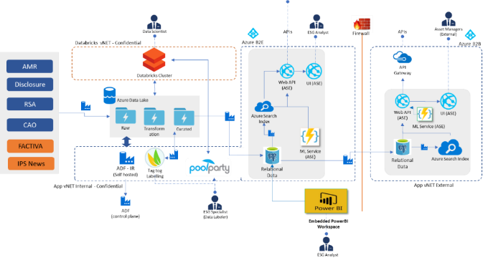

***Illustration 2: Overview of the current system***

### 3.1.2 Engagement Scope

Our understanding of engagement scope is explained below where we have summarized In Scope and Out of Scope activities:

#### In Scope

* The vendor team will work on the development and enhancement activities that includes:
  + Support, advise and provide hands-on support to IFC team development and deployment process on the IFC’s Machine Learning platform.
  + Work with IFC team to align the technology stack to cloud.
  + Actively work on integrating on prem data sources (structured and unstructured) with cloud-based ML/AI platform.
  + Build Text analytics platform focused on ESG documents and other relevant data sources.
  + Build UI and services to deliver the ML inferences to end users.
  + Augment the solution and delivery capacity on choosing the right model, labelling the data, preparing the training data set, training the model, testing the model, and deploying the model for end user consumption.
  + Automate the training process with MLOps concepts.
  + Apply reinforcement learning techniques to improve the quality of Machine Learning system.
  + Advice and design the solution to avoid model bias and skew on training data set.
  + Vendor will adhere to IFC’s processes and best practices during implementation. These processes may include automation of various phases of SDLC e.g., DevSecOps, Unit testing automation, Coding standards and automation of the functional and regression testing.
  + Comply with Information Security, Enterprise Architecture, Performance, Security, and Usability, coding standards, Documentation standards and Naming conventions as required by CIT policy.
  + Augment solutioning and delivery capacity by aiding through Center of Excellence (CoE), expert advisors, demonstrated process and technical accelerators.
  + Advise IFC on industry standards & best practices.
  + Define, design, and execute tasks as defined by IFC team.
  + Identify opportunities to improve technical competencies and suggest approaches to do so.
* The vendor team will provide production release support and upgrade activities that includes:
  + Ensure that production and non-production environments are up and working fine
  + Support other production releases and systems that depend on the web environments
  + Perform regression testing of functionality as needed
  + Support isolation/load-shift exercises
  + Support upgrades to the above-mentioned platforms by working with admins and other stakeholders
  + Perform code changes as needed to support upgrades and to be compatible with WBG standards.
  + Ensure Workflow notification of contents
  + Render UI and front-end design of the web applications/sites in desktop and mobile web version in live site in future Iterations.
  + Carry out new UI design implementation for existing web applications/sites
  + Create Menu, HTML, CSS, Page Navigator Components
  + Coordinate with Web Admins, users and other stakeholders for platforms maintenance and support
  + Provide web applications/site technical support (URL mapping, granting site access, broken links, archiving)
  + Carry out all initial engagements and follow up meetings with clients to review and discuss requirements as well as site progress once development begins
  + Create new web applications or revamping/enhancing existing ones
  + Create new web tools (blog, photo gallery, calendar, live chat using)
  + Develop of new applications and assisting power users
  + Fix problems in developed applications
  + Support the trainer to conduct users training for using web publishing applications
  + Conduct Quality Assurance and Testing of website prior to deployment in production environment
  + Document the work done at all stages of implementation
  + Support and manage user analytics data and tools
  + Develop artifact must support standard WBG’s browser(s)
  + Develop code should meet OIS security requirements
* The Scrum Master will perform project below activities that includes:
  + Coaching the team members in self-management and cross-functionality.
  + Helping the Scrum Team focus on creating high-value Increments that meet the Definition of Done.
  + Helping team to removal of impediments to the Scrum Team’s progress.
  + Ensuring that all Scrum events take place and are positive, productive, and kept within the timebox.
  + Helping the Scrum Team understand the need for clear and concise Product Backlog items.
  + Helping establish empirical product planning for a complex environment.
  + Facilitating stakeholder collaboration as requested or needed.
  + Guiding scrum team and organization to follow scrum practices and daily activities to actively promote prioritization, team readiness, and commitment for each Sprint.
  + Partnering with Product Owner to ensure continuous refinement of product backlog
  + Facilitating Scrum Agile events for the scrum team(s). Partnering with Product owners, Project Managers to communicate delivery of work product from the scrum team and escalating key risks and issues impeding scrum team effectiveness.
  + Overlapping with US team to sync up on the sprint progress.

#### Out of Scope

* Software/Hardware Licenses
* Creation or Automation of Unit, Functional, Regression, Performance Test Cases
* Compilation of test scripts and deploying test package into test environment
* Mobile applications development
* Performance assessment of any external interfaces or 3rd party components and database instances used by the system
* Anything that’s not mentioned in In-Scope

### Assumptions and Dependencies

The various assumptions and dependencies which are inherent as part of this engagement have been provided below:

* IFC to provide all requisite engagement related information, documents, access as needed.
* IFC to provision remote access via secured laptops 1 week prior to engagement kick-off to facilitate remote work environment
* IFC to sanction and facilitate the deployment of any software/tools that would be needed as part of this engagement
* While the overall scope of work is outlined above, specific work and related work products will be discussed with IFC Manager(s) and planned during program execution.
* All sign-off on deliverables will be done virtually due to COVID-19
* There would be a 2 weeks of lead time to start the engagement after SOW is signed.
* Offshore team will be overlapping with onsite team/ program team to do the handshake and support till 10.30 AM EST. Offshore team will start the day accordingly to complete the 8 hours productive work to meet the overlap.

## **Implementation Methodology and Execution**

Based on Cognizant’s understanding of the engagement scope and the clarifications provided by the CIT team during the pre-proposal conference, we have provided a comprehensive assessment approach that will enabled the CIT to achieve its business objectives. The approach incorporates our extensive experience and learnings gather from the existing MALENA engagements.

### Implementation Methodology

Our **Implementation methodology** for WBG Malena systems has been proposed to ensure following tenets are safeguarded:

* Team Collaboration (Enables Big Picture understanding, Single team approach, collective ownership, Impediment Removal)
* Grooming and Sprint Execution (Backlog grooming, Story volatility, Backlog visibility, DoD, DoR, REI)
* Risk tracking
* Tangible Measurement criteria
* Effective Work Planning & Execution
* Code Quality (Refactored, Scalable Code, Collective Code ownership, no manual intervention)
* Automatic provisioning, configuring of environment with continuous Integration and Deployment

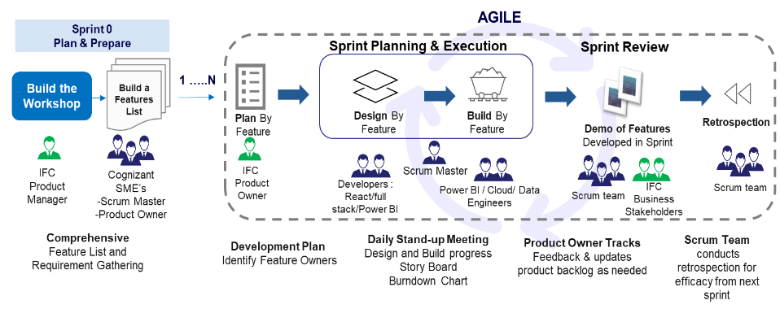

***Illustration 3: Implementation Methodology***

### Execution Model

* Proposed Implementation Methodology would have phases comprising MVP and MMF (Minimum Marketable Feature).
* Execution is done by scrum team through multiple sprints Assessment of current lay of land, Plan and Prepare a Roadmap and workshop is being done by Product Management team.
* Cognizant team will participate in roadmap/workbook activity as and when requested by WBG Malena program management team

The detailed view of execution model is given below:

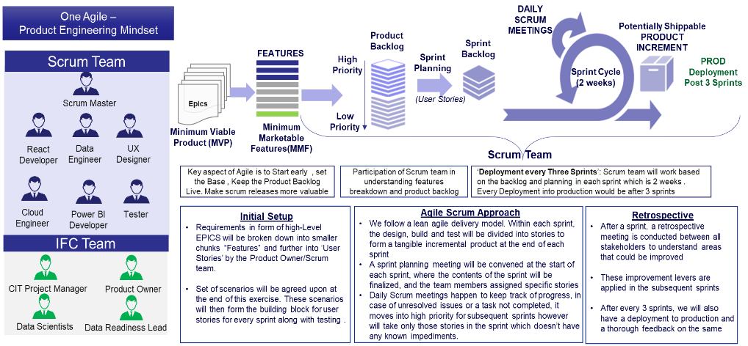

***Illustration 4: Execution Model***

### Scrum Teams Aligned to Value Streams

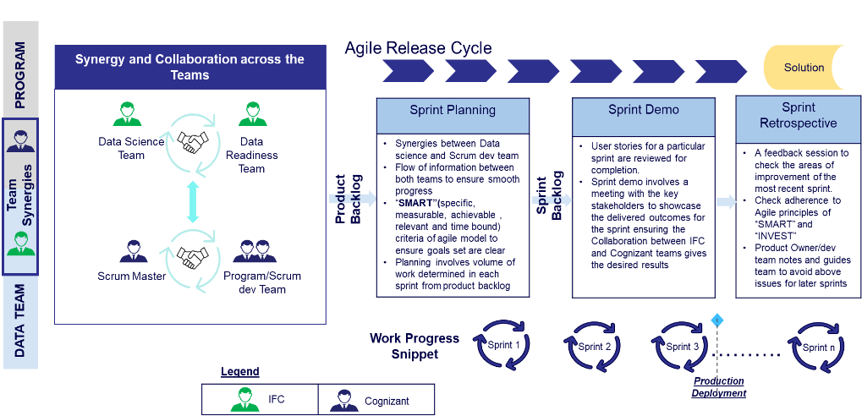

***Illustration 5: Alignment of Scrum Teams to Value Streams***

## **Engagement Governance**

Cognizant proposes a joint governance team with representatives from both WBG and Cognizant.



### Governance Model

The proposed engagement governance model will ensure that all stakeholders, from WBG as well as Cognizant, have clear visibility to the required level of details of the engagement, thus minimizing oversights and risks. These stakeholders include senior management and execution team members from Cognizant as well as WBG.

Provided below is a snapshot of the Governance Structure envisioned for the program delivery.

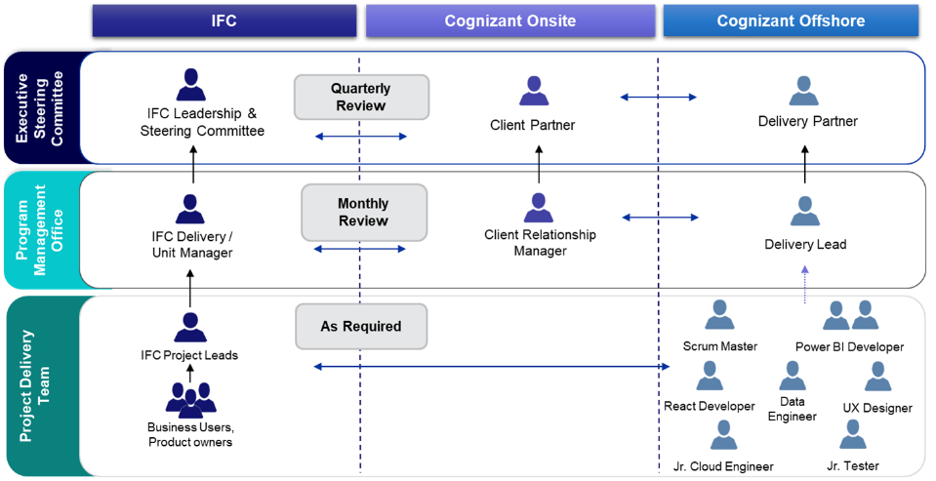

***Illustration 6: Governance Model***

Cognizant resources will report to WBG project manager for deliverables related communications and project work. Cognizant’s delivery lead will look after measuring, monitoring, and reporting the required SLAs to WBG.

Details of the governance levels are provided below:

* **Executive Steering Committee**
  + Approve overall program approach and set-up
  + Set strategic direction for the program
  + Strategic and enterprise focus
  + Periodic reviews of authority of the committees, and recommendations for continuous improvement
  + Review and approve financial performance, customer satisfaction, audit results, etc.
  + Continuous improvement plan
* **Program Management Office**
  + Support Steering Committee to advise on program direction and key decisions
  + Escalation to Steering Committee for formal decision
  + Provide input and recommendations
  + Provide Program Management best practices support and expert know-how
  + Monitor and report program level progress and accomplishments
* **Project Delivery Team**
  + Manage and execute day-to-day program delivery
  + Work on continuous improvement
  + Implement best practices
  + Provide relevant information and updates to Program Management
  + Escalate key issues and decisions to Program Management



### Change Request Management

**Change on resourcing demand:** The resource / skill requirement might change based on any change in requirements. If this results in resource ramp up or resource swap, Cognizant will take appropriate measures and will invoke the standard change management process considering the skills, profile level and associated rates.

# **Cognizant’s Capabilities and Experience in executing similar engagements**

This section highlights Cognizant’s capabilities and experience in executing similar engagements that has been requested in Qs. 3.1 in Annex D of the Requirements Matrix.



## **Cognizant’s Capabilities**

Cognizant is one of the world’s leading professional services companies, transforming clients’ business, operating and technology models for the digital era. We specialize in **helping Global 2000 companies transform their journey to becoming a “digital business”. Our services include digital services and solutions, consulting, application development, systems integration, application testing, application maintenance, infrastructure services and business process services.**

### UX Capabilities

Cognizant’s Digital Interactive practice comprises of 12000+ Digital Specialists servicing 750+ active customers across the globe. Among the 12000+ Digital Specialists, 4000+ resources are certified Digital professionals. We have been servicing 7 out of top 10 insurers in the US with an experience in delivering 5000+ Digital projects across 300+ customers in Insurance and Financial services industry. At Cognizant digital Interactive we assemble a global network of systematic thinkers and storytellers to design and deliver experiences with business impact. Our end-to-end practice includes foresight strategists, anthropologists, experienced designers, and technologists, all working together to ensure that experience design retains integrity in delivery

***Illustration 7: Cognizant’s Digital Interactive practice snapshot***

We are one of the largest UI/Design Services groups in the industry, helping our clients create a data-driven multi-screen Digital Experience. Our key differentiators include our design experience across front-end technologies. Cognizant has a strong global talent pool designing and developing world class User Experience solutions across technology platforms & devices and focuses on bringing to life, carefully engineering multi-channel user experiences – with a fundamental philosophy of “Design led Development”. We have a 4000+ team of UI Architects, Web Consultants, Technology Leads, and Developers in different skill sets ranging from a plethora of HTML-CSS, JavaScript Frameworks (client side & server side) including React, Angular etc. Mobile Hybrid solutions, Adobe Suite of Products and Open-Source Technologies (Node, PHP, ROR, etc.) and Accessibility Experts.

Of the **1200+ UI projects delivered**, we have over 700+ catering to multi-device solutions spanning across various flavors of Responsive Web Design (Plain Vanilla Responsive Design, Responsive with Server-side Detection, Progressive Enhancement, Graceful Degradation etc.)

### Web Development Capability

We are one of the largest UI/ Services groups in the industry, helping our clients create a data-driven multi-screen Digital Experience. Cognizant has **800+** strong React team designing and developing world class User Experience solutions across channels & devices and focuses on bringing to life, carefully engineering multi-channel user experiences – with a fundamental philosophy of “Design led Development”.

Cognizant has a team of 5000+ team of Strong team of Front-End Architects, Digital Consultants, Web Specialists & Developers. We have a very strong resource pool for handling some of the key UI solution spread as illustrated below:

* Angular – 800+ resources
* ReactJS –800+ resources
* RWD – 2500+ resources
* NodeJS – 150+ resources

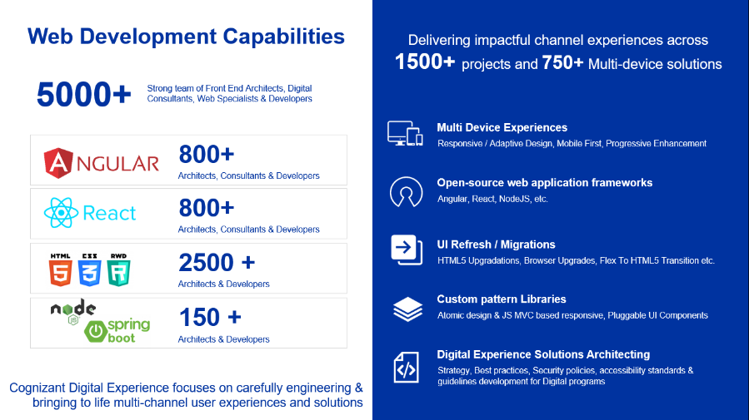

***Illustration 8: Cognizant’s Web Development Capabilities***

### Data Science Capabilities

**Cognizant’s AI & Analytics practice:** Cognizant’s AI&A (Artificial Intelligence & Analytics) practice is 33,000+ consultants strong and is one of the largest Analytics Practices in the Industry. The practice currently has more than 650+ active customers including several Fortune 500 companies and 150+ IP based Assets (Platforms, Solutions, Tools and Frameworks). The practice has an organizational structure with dedicated ‘Service-Lines’ to drive growth in various segments - Data warehouse and Business Intelligence, Performance Management, Business Analytics, and Information Architecture. Cognizant has a credible track record across our overall customer base, which is echoed by the analyst community and prestigious industry awards.

***Illustration 9: Industry and Partner recognitions***

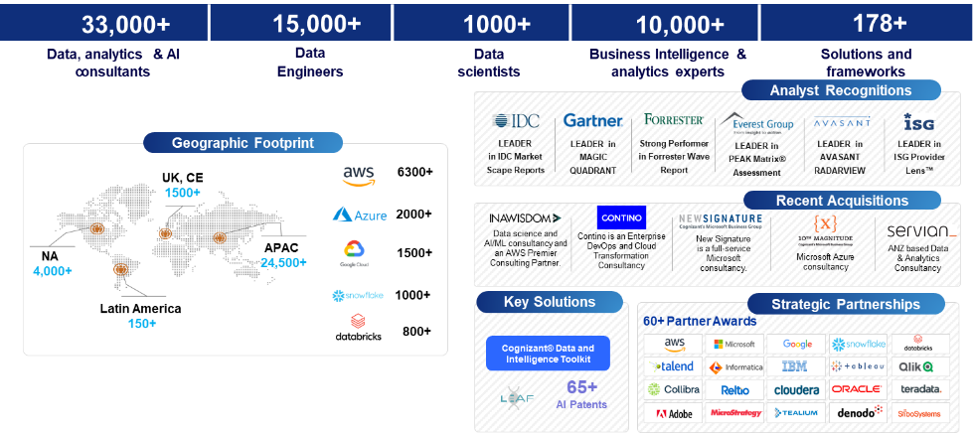

***Illustration 10: Cognizant’s Data Science capabilities snapshot***

Besides the capabilities highlighted above, Cognizant also has a unique ability to support across the Analytics Value chain, as highlighted by the illustration below:

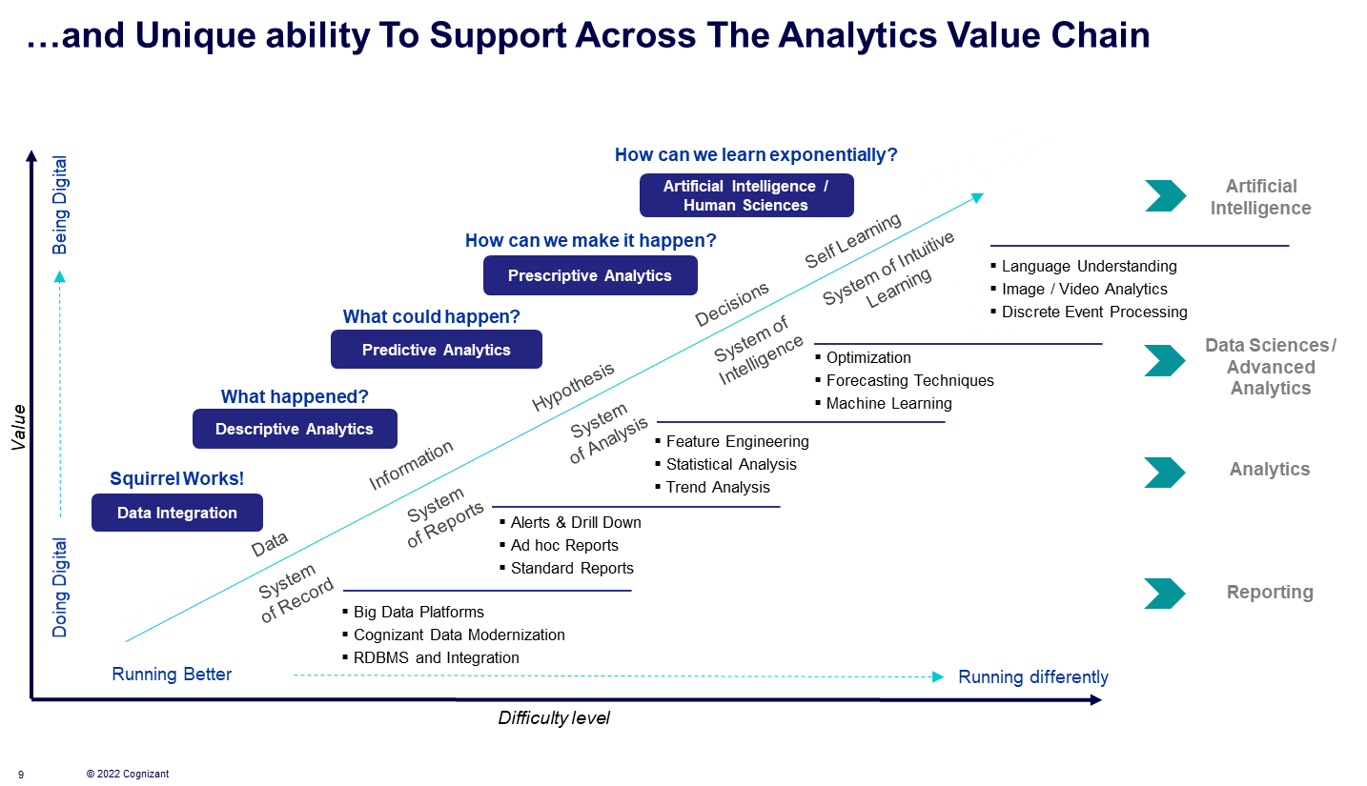

***Illustration 11: Cognizant’s ability to support across the Analytics value chain***

Cognizant also has a powerful, patented **Learning Evolutionary Algorithm Framework** (LEAF), which uses advanced evolutionary algorithms and deep learning to produce actionable results from complicated, multivariate problems. Further details have been provided in the illustration below:

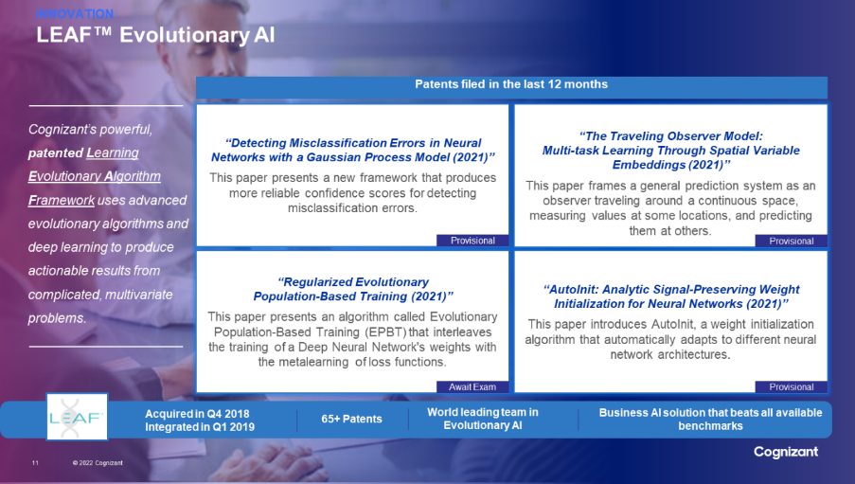

***Illustration 12: Innovation - LEAF™ Evolutionary AI***

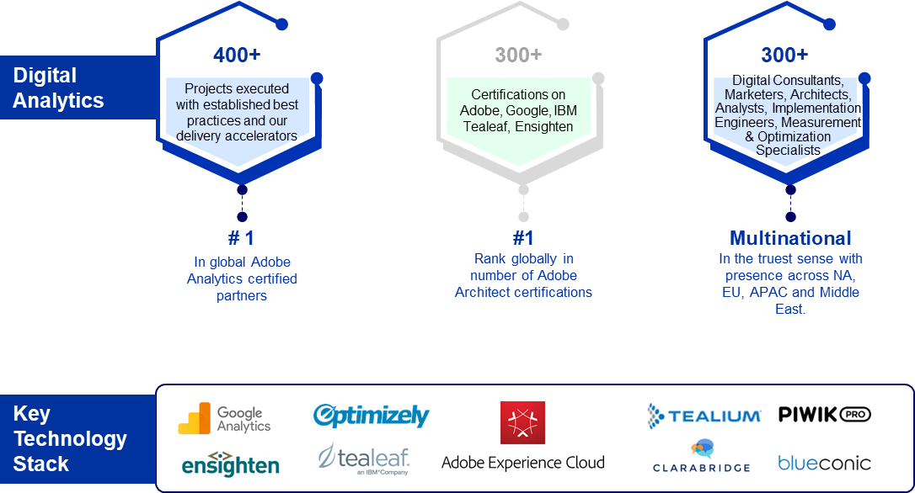

**Accolades:**



***Illustration 13: Digital Analytics capabilities and experience***

### Azure Data Capabilities

Cognizant has a long-standing partnership with Microsoft, as illustrated below:

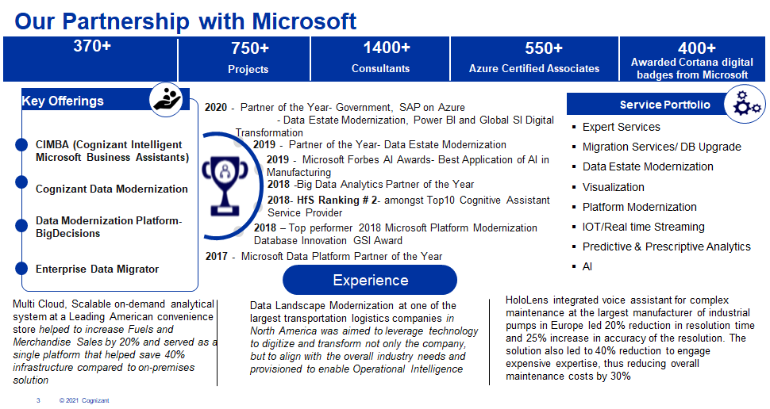

***Illustration 14: Cognizant’s partnership with Microsoft***

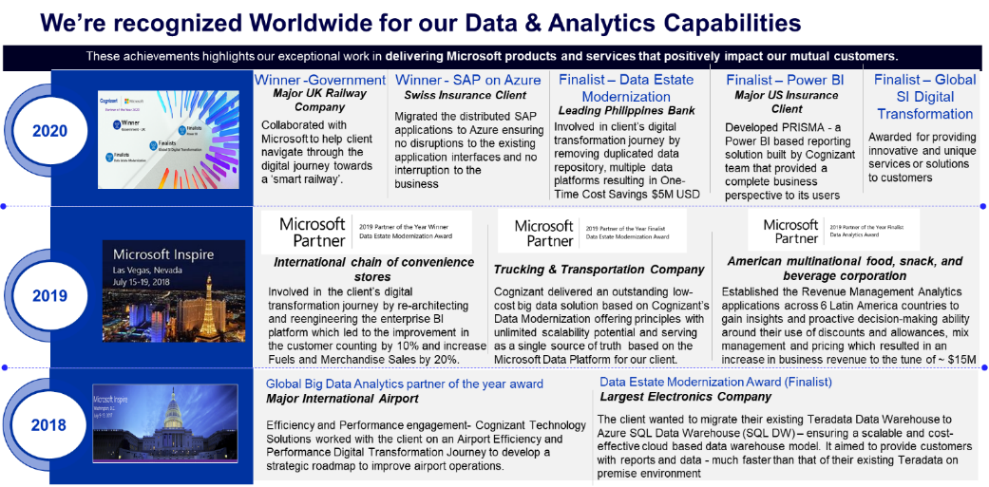

***Illustration 15: Cognizant is recognized worldwide for our Data & Analytics capabilities***

#### Azure Synapse and ADF Best Practices

**Azure Synapse**

* Use Replicate Distribution for Small Dimension/Lookup tables, so that it will be join compatible when joining with larger transaction/fact tables. Also defined correct Hash ID based on the column usage in different operation usage
* Consider Clustered Column Store Indexes for production tables to enable compression with fast query execution
* Use partition for large tables and it’s recommended to use date column for partitions
* Use Active directory managed login for developer
* Use Data masking for PII data
* Use External table methods for Fast Data Uploading Strategy (Polybase)
* Enable statistics in Database and update the statistics in regular interval
* Mixed workloads can pose resource challenges on busy systems. Separating DWH activities, (loading/transforming/querying data) ensures that enough resources exist to hit SLAs. Best practices for workload management would be followed
  + Workload Classification: assigning a request to a workload group and setting importance levels
  + Workload Isolation: reserves resources for a workload group
  + Workload Importance: order in which a request gets access to resources

**Azure Data Factory**

* Use ADF variable name to pass Parameters such as schema name
* Use SP's in ADF lookup activity instead of writing hardcore query by this we can avoid making changes in the pipelines
* Use Dataset parameters to pass the values in copy activity such as ADLS path, Schema name, folder name
* Use multiple partition in Data flow for faster insertion of larger file in Stage table
* Use Managed Identity for linked service for Database connection
* Use Azure key vault for saving Authentication values
* Azure integration runtime needs to be configured with at least 24 cores and with compute type as compute optimized to increase the performance of Data flow activity in ADF

### Power BI Capabilities

Cognizant’s Power BI practice has 700+ associates and 60+ Power BI Certified associates. We differentiate ourselves by leveraging in house Microsoft partnership within Cognizant for consulting, review and access to Microsoft’s product teams, and Power BI best practices for governance, design, build, test, and deployment.

**POWER BI:** A suite of business analytics tools to analyze data and share insights. Monitor your business and get answers quickly with rich dashboards available on every device.

**Our service offerings:**

* Power BI Integration with existing architecture
* Management and Configuration of Power BI service
* Advanced Dashboard development
* Analysis Services (Cube design & DAX development)
* Power BI Reports Testing & Deployment
* Performance Tuning
* Custom visuals Development

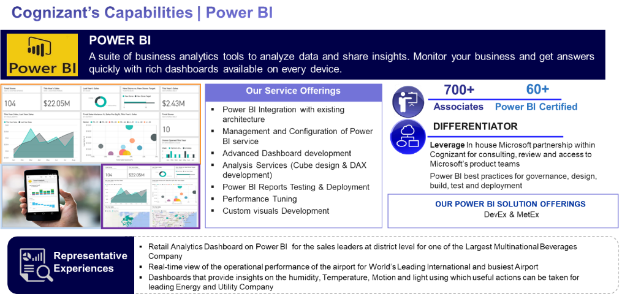

***Illustration 16: Cognizant’s Power BI capabilities***

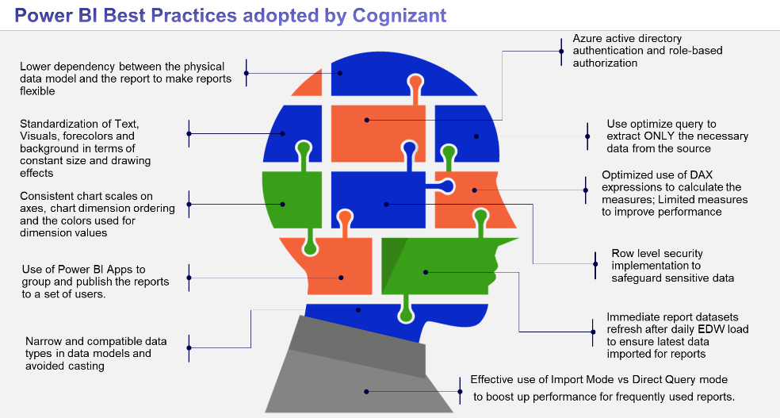

***Illustration 17: Power BI practices adopted by Cognizant***

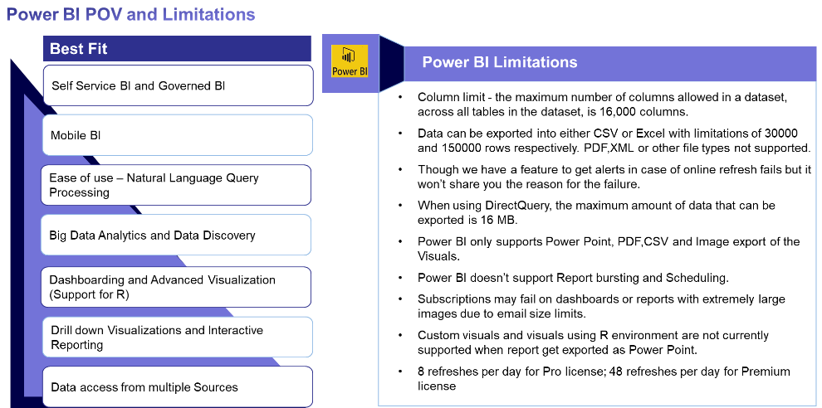

***Illustration 18: Power BI POV and Limitations***

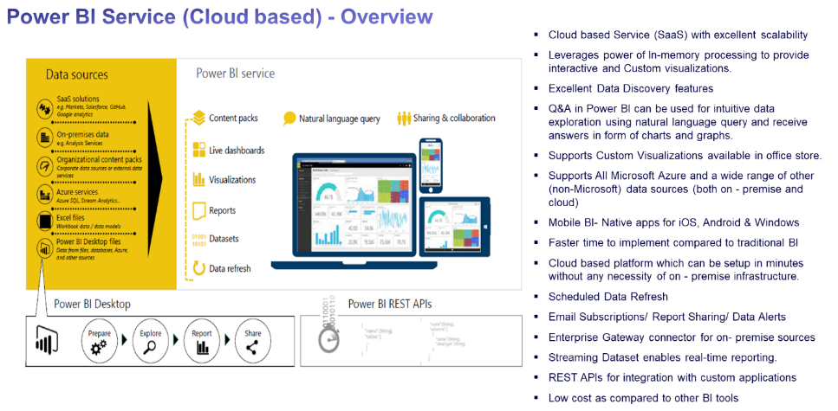

***Illustration 19: Power BI Cloud-based Service overview***

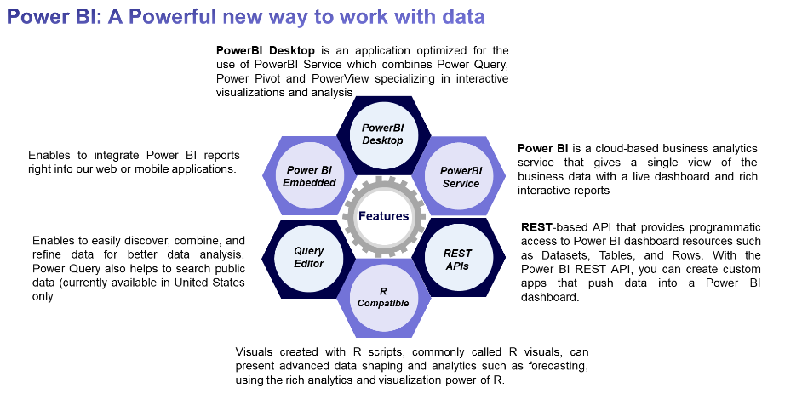

***Illustration 20: Power BI provides a powerful new way to work with data***

## **Cognizant’s Experience in executing similar engagements**

Cognizant has successfully executed similar engagements in the recent past both at World Bank as well as for other clients. Some of the key engagements and success stories have been illustrated below:

### Experience at World Bank

#### MALENA Success Story

|  |  |
| --- | --- |
| **Business Drivers** | * MALENA is a component of IFC’s EM ESG data strategy created to enable IFC to provide holistic solutions for ESG integration in capital markets. As efficient functioning of capital markets relies on publicly disclosed information, IFC is also supporting a complementary initiative to MALENA to increase EM ESG data coverage by engaging the services of an ESG data provider to expand and deepen the coverage of EM ESG data consistent with IFC’s ESG Performance Indicators. * The purpose of the MALENA platform is to analyze the different types of data in order to come up with better data-driven business decisions. |
| **Solution Highlights** | * The data is then transformed by Azure Data Factory software into the Azure Data Lake. * The Azure Data Factories helps to ensure the confidentiality of the transferred data, as well as the ability to have several pipelines simultaneously. * The usage of Azure Data Lakes helps to store data of any size, shape, and speed, and do all types of processing and analytics across platforms and formats. * Data Modeling and Training are hosted in Azure Data bricks. Once data processing done, final data modeling output will be stored in Azure Postgres SQL database. * The Azure Key Vault is responsible for the security of the secrets, such as passwords and keys. * The Azure PostgreSQL is responsible for the external data publication and internal data storage. * Microsoft Power BI is used for visualization& reporting purpose and source will be consumed with Azure Postgres SQL * Azure Function is used for executing the ML prediction service (sentiment) from Data modeling outputs which is be exposed with Azure web API internally and externally |
| **Key Highlights** | * Cognizant is key driver in implementing the major functionality and revamping the new user interface in MALENA * Tester from Cognizant is working closely with developer and data scientist in improving the data quality * Cognizant team is playing significant role in solution designing, development, implementing machine learning model, testing and management of this product. We have our footprints from Management role to technical experts. (Scrum Master, Cloud Engineer, Data Engineer, Application developer, Tester and Data scientist) |
| **Business Outcomes** | * MALENA helps users analyze large quantities of unstructured technical and complex ESG text, compare due diligence findings with historical data, and spot ESG risks. * MALENA identifies and extracts key information and presents this in accessible and intuitive formats. Users can save time, unlock institutional knowledge and insights, conduct sound assessments, and develop effective recommendations. |

#### World Bank Intranet Modernization

|  |  |
| --- | --- |
| **Business Need** | * Every Geographical Region and Department has its own solution to deliver information to the employees. The One Intranet Project envisions delivering a worldwide Intranet portal that provides Social and content publishing capabilities * Ability for staff to access information across geographies / business lines / area of expertise to know more about organization and collaborate better * Migration of legacy data to the new One Intranet platform * Turnaround time of a portal for any specific unit/department to be reduced * Migrate Network File Share to SharePoint Online |
| **Solution** | * Disparate legacy platforms consolidated to SharePoint * Enterprise wide Content Type Hub creation to propagate changes across hundreds of sites * Provision for Geographical Regions and Departments specific implementation to comply with banking regulatory requirements * SharePoint Framework (client-side web parts) based implementation in line with performance and security best practices suggested by Microsoft * Twitter, Yammer, Facebook integration made easier * Migrate FileShare to SPO using Skysync, executed in Factory model * Team Size: 47 – Onsite: 10, Offshore: 37 * Project Duration: 51 Months until June 2021 |
| **Challenges Faced** | * This was first of its kind in Cognizant to build widgets using SPFx when this project was started. Team had to self-learn and deliver in real quick time * Had a set benchmark of page load time which is < 3 secs at HQ and 5 secs at country offices. Deployed multiple strategies to reach this benchmark * First team in Cognizant to use SkySync tool for fileshare migration and had less time to learn and implement |
| **Technology Stack** | * SharePoint Online * SPFx, React JS * C#, ASP.NET * SQL Server 2012 * Html 5.0, CSS 3.0 * MS Azure * AWS |
| **Benefits to Client** | * Turnaround time to create a website with pre-defined templates reduced to 30 minutes * Enhanced user productivity by way of personalized content delivery, better user experience, seamless navigation, and better social collaboration features * Cost savings of $1.5MN per year realized in terms of license cost savings through the Jive migration initiative. * Migrated ~80TB data and 60 million files from file share to SPO |

### POWER BI Experience

#### #1: Embedding Power BI Reports into Third Party App

|  |  |
| --- | --- |
| **Business Drivers** | * Once Report generated publish to Power BI service * Front end team connect to Power bi service using API’S * The particular report will map the Report ID, Dataset ID, Group ID with the API and going to another configuration AEM whole functionality called POWER BI Embedding. |
| **Solution Highlights** | * Report implemented based on the business requirements * Users can slice and dice data from the given filters * Security is must while generating a report only the particular user can see the data not all data * Changed the environment details like Dev, QA, UAT share the report to cloud * Sponsorfit app used for external and internal users’ purpose and reports will be available in Power BI service as well as Sponsorfit also.   **Architecture:** |
| **Key Highlights** | * ~29 reports * 3 Workspaces - 3 DB server * 3964493 Business Users * Snowflake (X-small) 1.38 B of data |
| **Business Outcomes** | * Generates the Monthly/Quarterly/Annual Reports efficiently |

#### #2: Power BI Dataset Refresh through Power Automate

|  |  |
| --- | --- |
| **Business Drivers** | * More than 100 users * Dataset needs to be refreshed manually * Not ideal to provide pro license to all |
| **Solution Highlights** | * Created a Power automate job * Business users logs in with Power BI credentials * The trigger hits Power Automate * Power automate job gets authorized by the developer credentials * The respective dataset gets refreshed through Power BI REST API call   **Architecture:** |
| **Key Highlights** | * ~30 reports * 3 Workspaces - 1 Prod DB server * ~100 Business Users * 1 GB of Database |
| **Business Outcomes** | * Pro license cost saves for 100 users * User gets dataset refresh option with view permission |

### NLP Experience

#### #1: Digital Content Ranking Program

|  |  |
| --- | --- |
| **Business Drivers** | * **Evolving process**: There were no clearly set user stories, and since last one year, this required continuous improvisations to set acceptable user stories. * **Identifying the right data strategy:** It was not only about developing a solution, rather setting up the right data pipeline, choice of algorithm etc. * **Computing resources:** Most ML processes are computed intensive and time taking. Hence, we needed series of experiments with our algorithms to meet the given infrastructure and create the best possible efficiency of the running solutions |
| **Solution Highlights** | * Automated tagging of important keywords in a document and content summarization * Make user search string meaningful for effective search result * Auto suggest & type ahead functionality, Acronym based search * Suggestive navigation & recommended content based on search behavior * Natural language processing & Semantic search * Chabot (Future state)   **Technology Stack:** Python, Machine Learning, NLP, AWS Comprehend, AWS S3 and AWS Kendra |
| **Key Highlights** | * Intelligent Ranking System * Smart Tagging of document content * Automated content suggestions and recommendation system |
| **Business Outcomes** | * Ease of content publishing * Time savings for advisors * Aiding call abatement and reduced human interference |

#### #2: Identify emerging risks with Chat Monitoring of Credit card customers

|  |  |
| --- | --- |
| **Business Drivers** | * Client uses the Chat Service for complains, issues, query, support etc. * Develop an automated system using Machine Learning to find emerging topics for fixed time interval of two weeks. * Helps to find the potential pain points for customers at the earliest * Issues can be related to card benefits not working, technical glitches, reward points missing etc. |
| **Solution Highlights** | * Collect two weeks of Chat data from Database. * Separate the Customer and client’s care personal chat text data. * Filter the data based on keywords used by Customer Care personal like investigation raised, sent to backend team etc. * Apply Tfidf Vectorization, Clustering and top 10 words used for each cluster * Send the clusters with higher Week 2 to Week 1 transition as alerts.   **Technology Stack:** Hive, Python, Machine Learning |
| **Key Highlights** | * Improved better visibility of recent issues faced by client’s users * Model helps to find emerging topics and alert the business for quick resolution * Helps with maintaining brand value or avoid financial loss due to card cancellation |
| **Business Outcomes** | * Helps to manage brand value or image * Avoid financial loss, fines or penalties via card cancellation, service dissatisfaction caused due to card issues |

#### #3: Audit Review Tool

|  |  |
| --- | --- |
| **Business Drivers** | * Every year FM staff receives approximately 4,000+ audit reports, accompanied by 3,000+ management letters to review findings, observations, and recommendations, it is a time-consuming process. ART tool reduces the manual effort and automate the process end to end using deep learning and regex. |
| **Solution Highlights** | * ART Tool - Applying AI & ML to the business problem and implemented the ART process automation for audit review and FM can upload audit documents, management letters and recommendation letters to ART system and analyzes and understand the document content. * ML model is used to process all documents based on the trained model to extract opinion, entities, sentiments, risks, etc. * Extracting key attributes using complex regular expression and automating the identification process * Using Deep learning classification models to classify the extracted text into predefined category there by automating the tagging process.   **Technology Stack:** Python/Spacy/NLP/BERT/ AWS Cloud/SQL |
| **Key Highlights** | * Regex, Deep Learning Classification * Extracting and classifying Key attributes using regex expression and deep learning |
| **Business Outcomes** | * Improvement in the review time of Audited financial statement by financial management specialist, which reduced from days to hours. * Reduction in manual errors * Integration with Financial Management (FM) system Application * Automation of generation of letter to TTL |

### MLOps Experience

#### #1: Automated model management and MLOps for US Pharma Major

|  |  |
| --- | --- |
| **Challenge** | * The customers did not have the right insights at the right time due to long delay in syncing the predictive model with the recent changes in data. For this the highly skilled Data Science team’s bandwidth was being lost in conducting foundational activities than on building actual business value. The delay in the handoff between IT and business was impeding the customers from realizing the immediate benefits |
| **Solution** | Cognizant leveraged an Azure based MLOps solution to automate the end-to-end ML process using a combination of Cognizant Data Science, AI Engineering Skill sets and Microsoft Azure Suite with below features:   * Automatic triggering of the model retraining based on the changes in the source data driven by a configurable threshold factor * Automatic model retraining, model evaluation and deployment * Auto ML leveraged to identify the right model for the given data and promote the most significant model into production |
| **Key Highlights** | * Collaboration and sharing of ML pipelines * Model portability across a variety of platforms * Tracked, snapshot & managed assets used to create the model |

### Azure and Other Similar Experience

#### #1: Data Landscape Modernization @ Logistics company

|  |  |
| --- | --- |
| **Business Drivers** | * The client's data modernization program vision was aimed to leverage technology to digitize and transform not only the company, but to align with the overall industry needs. * They were faced with issues pertaining to an outdated architecture (10-year-old), with data scattered across multiple systems and lacked data quality and security elements. |
| **Solution Highlights** | * Takes advantage of the leading capabilities of the Microsoft data platform on premise and on Azure cloud for the client’s mission critical data warehouse applications. * Low-cost big data solution with unlimited scalability potential and Data solution that allows you to store unstructured, semi-structured, structured, social, web, Machine-to-Machine (IoT) * Store, manipulate and derive insights from the extensive data and Simplified access to analytics without data modeling constraints * Enriched analytics with untapped sources of information * Agile analytics at the speed of business * Incorporate enhanced data security/resiliency capabilities available in architecture |
| **Business Outcomes** | * 15+ data sources consolidated (plan for 10 more sources in line) * Low-cost big data solution |

#### #2: Document Classification and Processing @ A Leading Regional Bank in US

|  |  |
| --- | --- |
| **Objective** | * Client receives different types of loan documents through various medium like email, bulk upload, manual upload, scan etc. Before uploading these documents to RECWEB, documents need to be categorized into Doc category and sub-category from different stakeholders * Leverage AI/ML techniques to reduce manual effort in document classification and processing of Inspection notes |
| **Key Challenge** | * Document summarization in the Banking requires deep domain knowledge and necessary research to ensure accurate analysis |
| **Solution Highlights** | * Understand Current Process & Challenges including data sources, formats, volume * Data Set preparation – Ingestion, data cleaning and validation, Transform unstructured data to model features * Exploratory Data Analysis - Analyze visual summaries to understand patterns across different document classes, perform statistical analysis and prepare derived attributes * Document Classification Modelling – leverage deep learning capabilities to accuracy improvement with each iteration * Form field & Document term matching -Explore opportunities to improve the model and demonstrate the final model * Roadmap and strategy for deployment in production * Technology Stack: R, Factor analysis, NLP, Image processing, Deep learning and machine learning, Document Term matrix (Tf-idf, Term frequency, Sparse Text removal) |
| **Business Outcomes** | * Built a robust, flexible, and scalable document classification model leveraging key tenets of ML and AI * Greatly enhanced the processing capability of Inspection notes |

#### #3: Personalized Marketing @ A Top 5 Wall Street Firm

|  |  |
| --- | --- |
| **Objective** | * Restricted capability on analyzing customer and product data * Lacked model to dynamically capture customer profile characteristics and customize product offering * Absence of an enterprise grade analytical solution leveraging the best of breed ML technologies * Lack of a robust data management platform to handle large volumes of data across multiple channels * Client wanted to provide personalized marketing on web * A dynamic scalable solution was sought to market across the enterprise for multiple lines of business * Efficiency was a key focus area due to volume of data that had to be handled |
| **Critical Success Factors** | * Dynamic categorization of 90000+ Customer records * Identification of 9 customer categories * The solution built had enterprise level scalability |
| **Solution Highlights** | * Cognizant provided a cloud-based solution to the client to ensure scalability * Collected and refined customer data, product offers and past customer behavior * Leveraged latest Azure ML capabilities to provide dynamic categorization of customer based on profile attributes * Developed a multinomial logistic regression model to predict ad campaign performance * Refined solution efficiency by liaising with Microsoft on performance improvement opportunities |
| **Business Outcomes** | * Built a robust, flexible, and scalable document classification model leveraging key tenets of ML and AI * Greatly enhanced the processing capability of Inspection notes |



**Thank You!!**

***About Cognizant***

*Cognizant (Nasdaq-100: CTSH) is one of the world's leading professional services companies, transforming clients' business, operating and technology models for the digital era. Our unique industry-based, consultative approach helps clients envision, build and run more innovative and efficient businesses. Headquartered in the U.S., Cognizant is ranked 185 on the Fortune 500 (2021) list. Cognizant has been listed in Fortune’s Most Admired Companies in the world 12 years in a row. Learn how Cognizant helps clients lead with digital at www.cognizant.com or follow us @Cognizant.*